**Proceedings of ES2010  
Energy Sustainability 2010  
May 17-22, 2010, Phoenix, Arizona, USA**

**ASME ES2010-DRAFT**

energy return on energy invested: economic “top-down” vs. Life cycle “bottom-up” approach

carey alternate title suggestion:   
 Or ph alt:  
LCA w/ TEA - joining bottom up and top down whole system accounting  
 for total energy costs and defining standard measures of EROI and EIRR

Carey W. King

Research Associate

Center for International Energy and Environmental Policy

The University of Texas,

Austin, TX 78713 USA

Jay Zarnikau

Visiting Professor

LBJ School of Public Affairs and

Division of Statistics, College of Natural Sciences

The University of Texas

Austin, TX 78713 USA

**Phil Henshaw**

HDS Systems Design Science

Sustainability and Natural Systems Physics - Synapse9.com

New York, NY 10040 USA

# Abstract

Business investments rely on creating a whole system of different parts, technologies, field and business operations, management, land, financing and commerce using a network of other services. For a wind farm development, the typical life cycle analyses (LCA) focuses upon the principal technology inputs and their accountable embodied direct impacts. What, LCA omits is the direct and indirect impacts for the rest of the business system that operates the principle technology, the labor, commerce and other technology employed. That total environmental assessment (TEA), for embodied impacts of labor, technology and commerce can be calculated only by combining a “top-down” method of dividing up a business operation as a whole using econometric methods with a “bottom-up" method of adding up identifiable parts. The top-down technique gives an inclusive measure of average content. The bottom-up technique captures the more notable and directly identifiable individual parts. A refined estimate of the total comes from combining high and low precision measures indentified by each accounting method.

To understand how to compare energy invested and returned (EROI and EIRR) a generic business operation is dissected and different degrees of economic energy intensity to combine with direct energy measures. For some items we compare different choices for doing that. The model used is that of a generic "Texas Wind Farm" based on the JEDI business model using the VESTAS wind farm LCA data for the I/O table, as an example for a business model and industry.

**Keywords:** ­energy return, internal rate of return, net energy, energy economics

# 1. INTRODUCTION

This paper introduces a method for measuring total energy use by business systems, to help understand business risk exposures and to standardize a measure of energy return on energy invested (EROI). That prompts diverse questions, many of which will need further study, and reflects on internal financial rates of return (IRR) and levelized cost of electricity (LCOE). We suggest a small sample of the literature links between energy resources, technology and economic returns for reference [1-5].

Because there has been no standard way to define system boundaries, and what should be counted, the comparison of energy returns and financial returns for the same project has not been possible. We define a method for doing so, but as we address only one project we make no comparisons with others. Our results are similar to those of Costanza (4), whose method compared the energy intensities of whole economic sectors. Fig 1. shows his results in relation to the average economic intensity he found along with ours for the Texas Wind Farm project compared to the present world average economic energy intensity. This rough comparison can be improved with more attention to whole system measures.

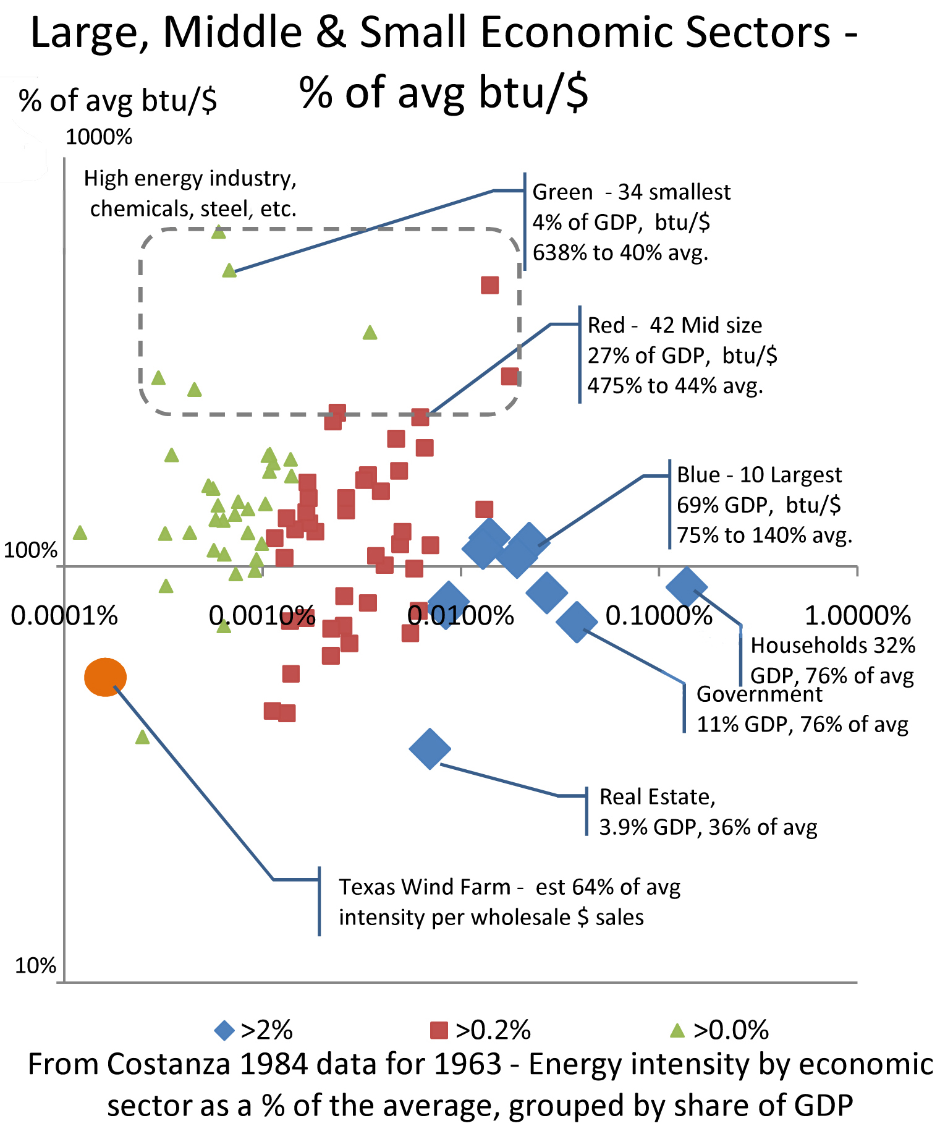

Fig. 1 - . Comparing scale and relation to average btu/$ for Costanza's economic sectors and our Texas  Wind Farm.  Key observations are: 1) producer sectors vary greatly in energy intensity, 2) the consumer sectors, households and government are about average.

The Costanzia data provides some basis for assigning different kWh/$ figures to costs of different kinds, with household and government sectors treated as about average.  In the general scope of things, it seems that consumer spending in a market economy would have about average impacts in any case, simply because all producer sectors are supported by it in direct proportion to their scale. consequently our approach is to treat all costs as having average impact intensity unless we find a reason otherwise.

## 1.0 Measurement Methods

We start from the complex system life cycle environmental assessment methods, LCA and TEA(14), for technology and whole system impacts respectively. We simplify them to their energy component, dubbed LCAi and SEA for System Energy Assessment. In looking for the correct boundary for measuring whole system EROI we break the whole system SEA into whole operating units SEA0,1,2 & 3. These correspond to the supply network, field operations, managing business and corporate levels of the business organization. LCAi corresponds to the direct energy consumption for making and using the principle technology for the field operations of a business.

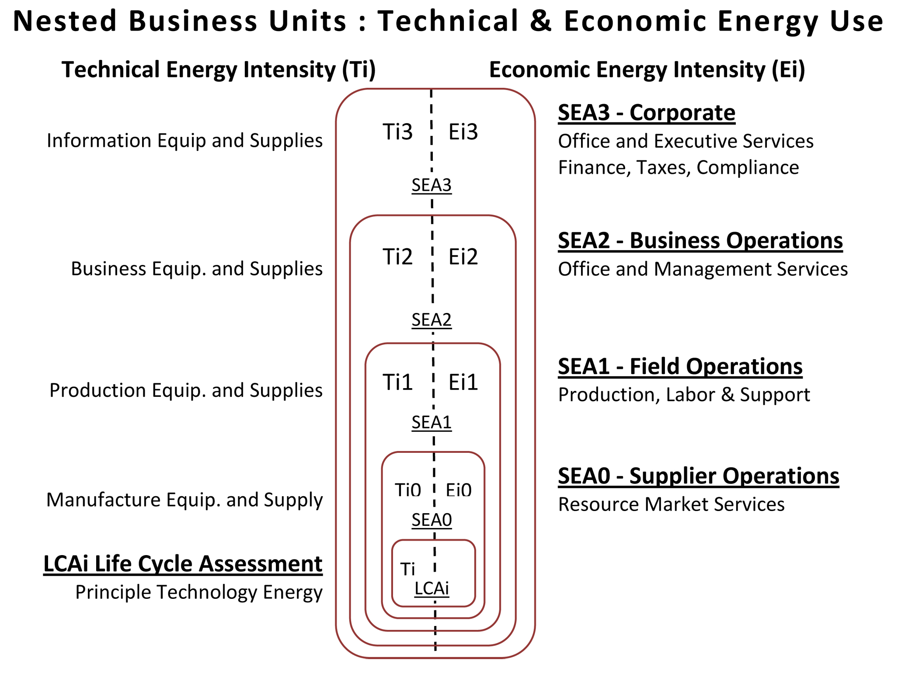

Fig. 2 - Whole System Energy Assessment (SEA) for a product adds the energy intensity of the various operating systems needed to produce it. To be comparable measures of different things would all need to measure the technology and economic energy used to the same market point of sale.

A 1st estimate could be the product cost, times twice the average energy intensity, and the general equation is: SEA# = ∑Ti's + ∑Ei's. The detailed estimate starts with the least inclusive and most precisely calculated component, the LCAi measure of direct accountable energy used for producing and operating the principle technology. All the other costs, the other technology, wages, financing, land owner payments, etc. are aggregated by the business unit they apply to and assigned an energy intensity for their cost. That value is chosen to be either above or below the average energy intensity for the whole economy, the nominal energy used to produce GDP (Wh/$).

**1.1 Analysis Approach**

The EROI for each SEA# level of business organization compares the accumulative energy cost (kWh) with the total energy produced (kWh). The money made from the wind farm investment ($/kWh) may have no bearing on EROI, of course. We explore some ways the real and perceived investment value might change when a better measure of EROI is available, comparing levelized costs and internal energy and financial rates of return (EIRR & IRR).

Many major issues are not considered in this presentation, but hopefully raised by it. Perhaps most important but least discussed will be how this method gives one a much more complete understanding of the lifecycle of the whole business as part of a whole changing environment. The ultimate goal would be to enable people to design businesses for a "better natural fit". For example, that wind generated electricity is a high quality energy source but also intermittent would mean there would be a high EROI value in fitting the producer to the user. There is also a high value in understanding the kinds of exposure to future cost inflation and other resource dependency, opportunity and mitigation costs and benefits as energy generally becomes more scarce, and business models need to change again and again

# 2. Analysis DESCRIPTION AND Background Assumptions

Blah blah maybe …

## 2.1 Background on EROI for Wind Turbines

The EROI of wind turbines has been calculated many times by many authors. It appears that the wide range of values could have to do with there being no standard of counting all the parts of the system that need to work as a whole, as the economic costs are commonly omitted. Kubiszewski et al. (2009) performed a meta-analysis to summarize the net energy of wind turbines based upon a suite of previous studies of 114 calculated values for EROI (see Figure Kubiszewski) [6]. There is tremendous variation in the EROI values, over an order of magnitude with values reported at over 100. The average EROI for all studies was reported at 25.2 although the average for operational LCAs (those based upon actual performance of a turbine) was lower at 19.8.

**Fig. 3 Kubiszewski.** The frequency distribution of EROI as studied in [6] shows the majority of the values are less than 40, although a few values were > 100 and many are < 4.

There is also a variety of parts of the business considered in the LCAs including manufacturing, business management, transport, construction, grid connection, operating and maintenance, and decommissioning. However, given all of the studies of the meta-analysis, Kubiszewski et al. (2009) show that 85% of the values for EROI of wind turbines are below 40, and this value may be considered an effective upper-bound to constrain the present analysis. Furthermore, they indicate a significant and unnerving difference between the two major methods for calculating EROI:

“Studies using the input–output analysis have an average EROI of 12 while those using process analysis an average EROI of 24. Process analysis typically involves a greater degree of subjective decisions by the analyst in regard to system boundaries, and may be prone to the exclusion of certain indirect costs compared to input–output analysis.” [6].

In order to understand how EROI can be used as a measure of more long range value than immediate financial returns is another complex subject, needing care to understand how to combine high and low precision analysis. We do attempt to do so,

**2.2 Initial Energy Flow Analysis of Wind – Nominal LCA**

Prior to combining it with the financial cost data from the JEDI wind farm model [15] we reviewed the results from the Vestas [7] project. TheEROI estimate from the process analysis LCA for the Vestas 2.0 MW turbine is 31, with the turbine generating 5,634,000 kWh/yr at a capacity factor of just over 32%. In total 13,100,000 MJ (3,640,000 kWh equivalent) of energy was calculated to be consumed for manufacturing and installing the turbine and transmission components (see Table Vestas LCA). Thus, the EROI = 31 is used as a starting value for incorporating the energy requirements of business operational units during a wind project.

**Table 1 - Vestas LCA.** The quantity of fuel consumed for a Vestas 2.0MW turbine has an energy content of 13,100,000 MJ costing approximately $150,000. Energy consumed is from reference [7].



In order to compare calculated EROI values with standard energy financial descriptors such as LCOE, a monetary cost value must be associated with each (see Figure EROI). Thus, the corresponding financial expenditure for the fuels is $147,960 as calculated by multiplying a market value of energy to each form of energy consumed during the wind turbine life cycle (see Table Vestas LCA).

s The results are described in Section ase (whcih eans you don'o shine, wind to blow, or fossil fuel to regeneratehumnas

**2.3 Energy Flow Analysis of Wind - SEA**

The System Energy Accounting (SEA) method uses the average energy intensity of the global economy to assign energy consumption to the monetary expenditures of the analyzed wind project. The average energy intensity of the economy, based upon power purchasing parity (PPP), was calculated using data from the United States Energy Information Administration (EIA) of the Department of Energy. The world gross domestic product (GDP-PPP) in 2006 was $59,939 billion ($2005) while consuming 472 quads of primary energy. [EIA International Energy Outlook 2009]. These values correspond to an energy intensity of 7,630 Btu/$ in 2006. Because the energy output of a wind turbine is electricity, we convert this value to units of electricity, or kWh (see Equation 1). However, the authors are well aware of the different monetary values that the market applies to different forms of energy (e.g. oil, coal, electricity, etc.), but the analysis of this paper is considered preliminary and does not make a distinction in value for different energy inputs and outputs [1, 5, 8].

$$E_{in} \left(\text{kWh}\right)= \frac{7,630 \text{Btu/\$2006}}{3,410 \text{Btu/kWh}}\left(\$ \text{spent}\right)$$

$=\left(2.24 \text{kWh/\$2006} \right)\left(\text{\$ spent}\right)$ (1)

The best way to describe the SEA analysis is by reviewing Table 2 showing columns for the Technology fuel use (Ti) and Economic fuel use (Ei), with the economic costs associated with teach item and the weighting factors that connect them. The weighting factors are in relation to the world average energy intensity of money, as noted in figure footnote #2.

The LCA fuel use data from Table 1 is the source of the LCA fuel use converted to kWh for the LCA level of business organization that is then also included in the totals for the four SEA levels.

That same data combined with the market prices of the associated fuels was used to determine the ratio of fuel costs to project costs for the principle technology, which turns out to be 40% of the world average kWh/$ and so the weight factor for Ti used for other technology purchased for business use is estimated as 40% of average for their cost. The same kind of procedure could be used for the Ei values in the table, to estimate the economic energy use of each kind of cost the technology price. We did not see a clear reason to give any of the Ei estimates a value other than "average" and so their weighting factors are all 1.

For direct fuel use weighting factors the same data in table 1 was used to estimate the kWh equivalent of energy consumed with purchased fuels and used to estimate the weighting factor of 4.6 to indicate that money spent on fuels listed in the JEDI cost table would use that much more than the world average kWh/$.

|  |  |  |
| --- | --- | --- |
| **JEDI project - simplified cost data** |  |  |
| **Wind Farm Project Data** |  |  |
| **Project Location** | **TEXAS** |  |
| **Year of Construction** | **2009** |  |
| **Total Project Size - (MW)** | **100** |  |
| **Number of Projects** | **1** |  |
| **Turbine Size (KW)** | **2,000** |  |
| **Number of Turbines** | **50** |  |
| **Installed Project Cost ($/KW)** | **$2,032** |  |
| **Operations and Maint. ($/kW)** | **$19.82** |  |
| **Money Value - (Dollar Year)** | **2008** |  |
| **Project Cost Data** |  |  |
| **Construction Costs** | **Cost** | **Per KW** |
| **Equipment Costs** |  |  |
| Equipment Total | $152,285,602 | $1,523 |
| **Balance of Plant** |  |  |
| Materials Subtotal | $31,911,242 | $319 |
| Labor Subtotal | $13,363,307 | $134 |
| Development/Other Subtotal | $5,679,841 | $57 |
| Balance of Plant Total | $50,954,391 | $510 |
| **Total** | $203,239,993 | $2,032 |
| **Operating and Maint. Costs** | **Cost** | **Per KW** |
| Labor/Personnel Subtotal | $428,767 | $4.29 |
| Materials and Services Subtotal | $1,553,496 | $15.53 |
| **Total O&M Cost** | $1,982,263 | $19.82 |
| **Financial Parameters** |  |  |
| **Debt Financing** |  |  |
| Percentage financed | 80% |  |
| Years financed (term) | 10 |  |
| Interest rate | 10% |  |
| **Tax Parameters** |  |  |
| Local Taxes | $1,098,600 |  |
| **Land Lease Parameters** |  |  |
| Land Lease Cost (per turbine) | $6,000 |  |

Table 2 - Simplified *JEDI Cost Data used for Table 3*

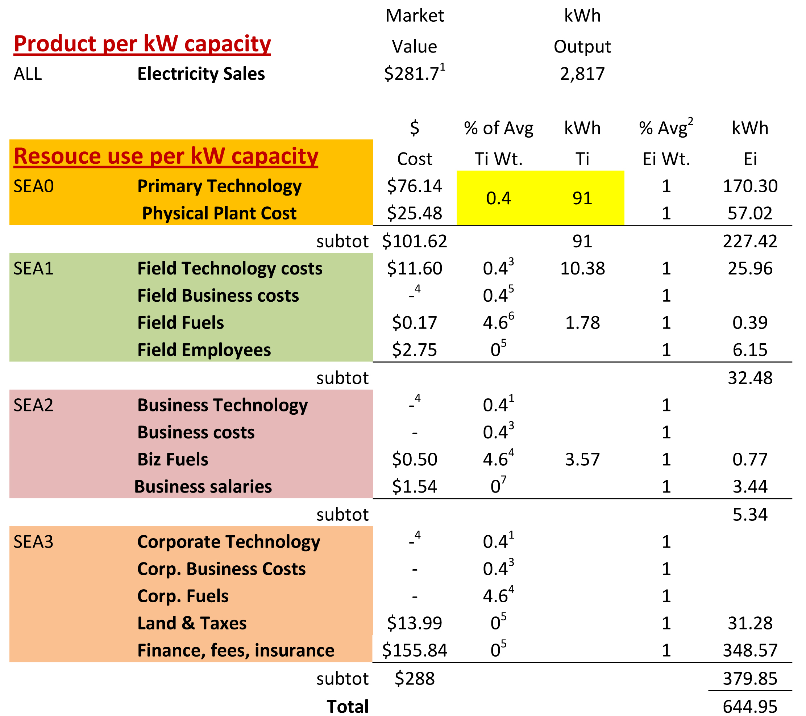

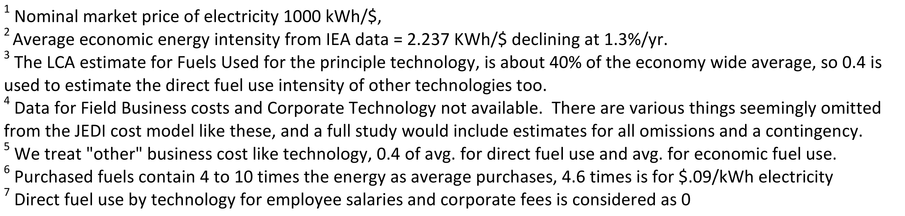

Table 3 - *Technology and Economic fuel costs per KW (Ti and Ei) of installed generating capacity. The fuel directly used by technology* comes entirely from physical sources, and money paid for it goes entirely to people for providing other economic services that also consume energy. So, here is one column for costs ($) and a second columns each for Ti and Ei for the weight applied to translate to or from the $ costs. The two energy streams don't cross, the direct Ti uses would reduce the economy wide average, but likely to be much less than the uncertainty of the measures.

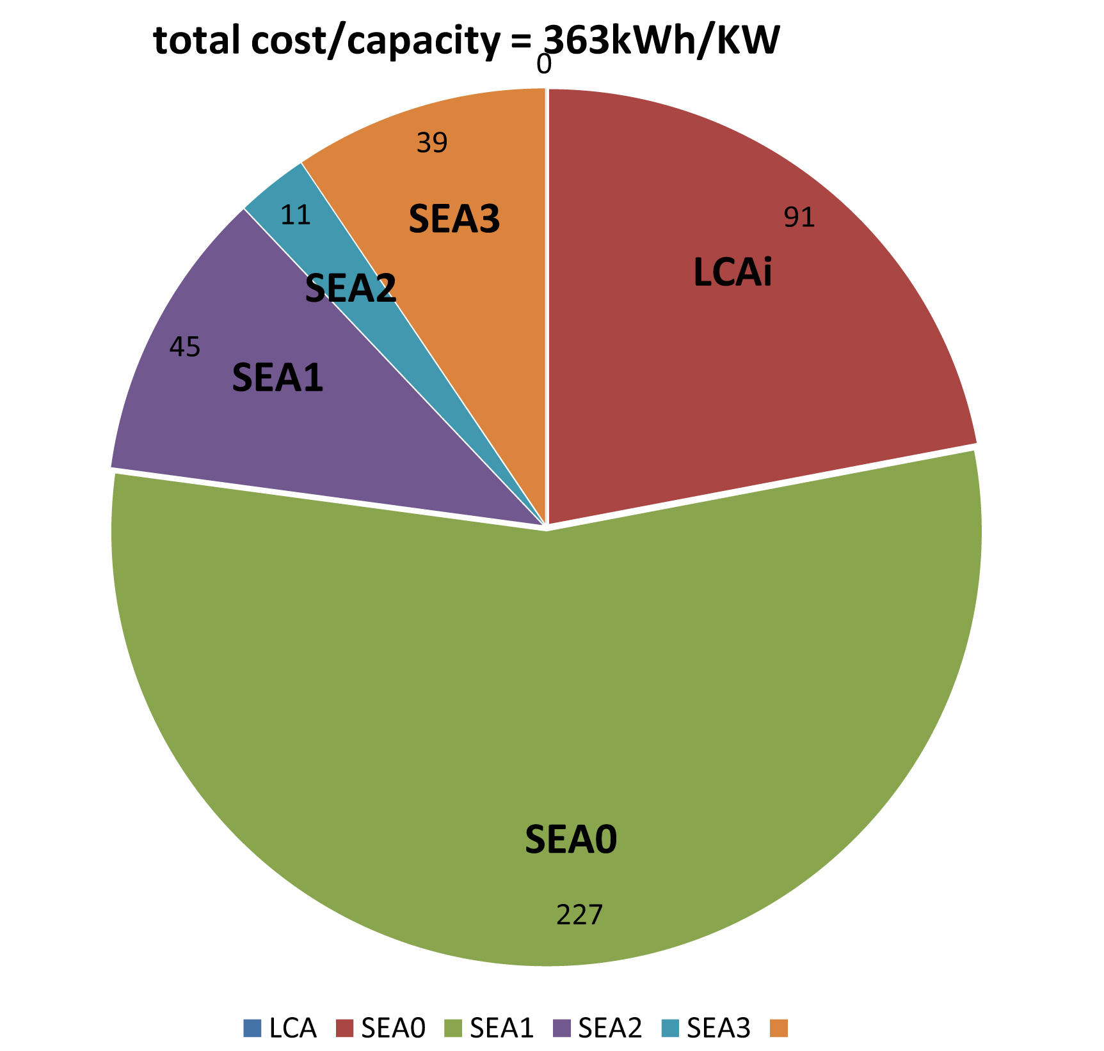

Fig. 4 - *Total kWh cost per KW unit of generating capacity,*

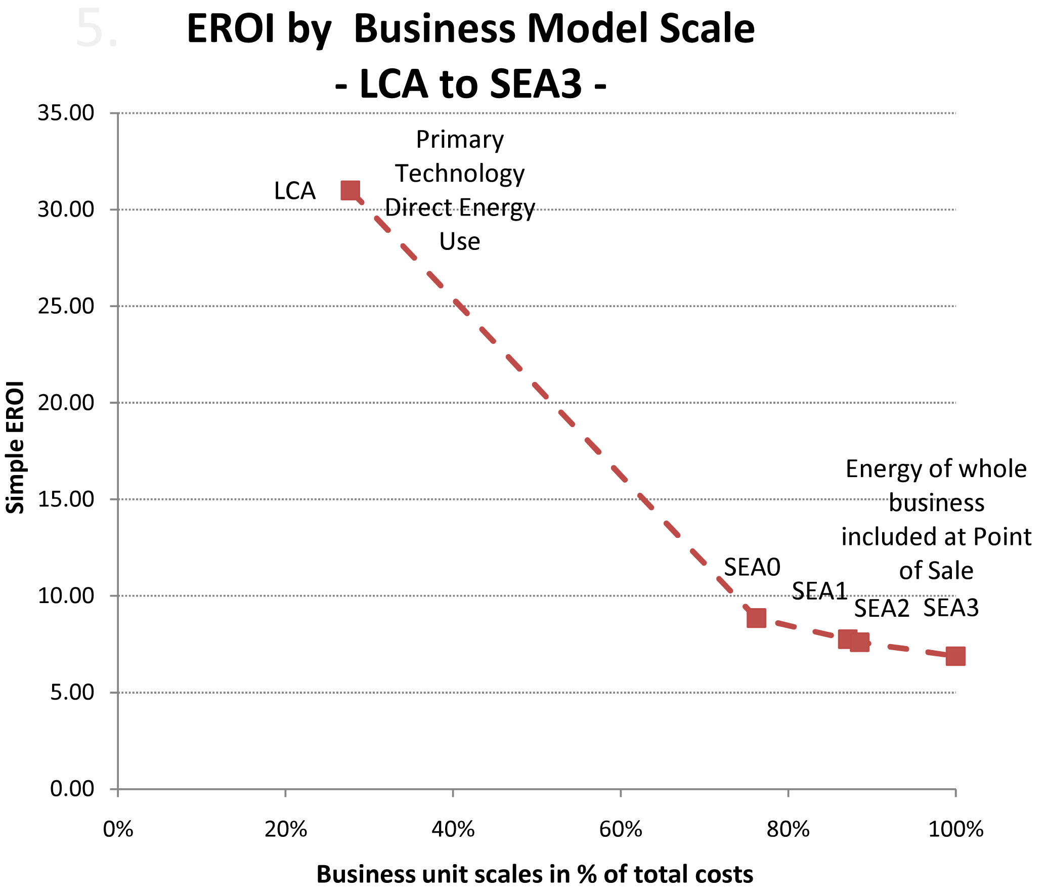

Fig.5 - *Total kWh cost per kWh energy sales*



**Figure Methodology.** Each subsequent level of analysis incorporates the energy inputs of all previous levels. The left-pointing arrow for the first level, LCA, indicates that the energy consumption is base information obtained via the process LCA [7], and a monetary value is calculated from the energy types consumed. The right-pointing arrows for all other analysis levels indicate that monetary costs are used from financial analyses [9, 10] to multiply by the average energy intensity of the economy to obtain an estimate of energy inputs.

## 2.4 Cost Flow Analysis of Wind

The Wind Energy Finance Model of the National Renewable Energy Laboratory or NREL [X] was used estimate the annual cash flows corresponding to the energy flows discussed in Section 2.3. Capital and operating costs obtained from the NREL JEDI model were input to the Wind Energy Finance Model. A 3% inflation rate as assumed. A typical capital structure was adopted, with 20% equity (with a target internal rate of return or IRR of 10%) and 80% debt (with a 6.8% interest rate on the debt financing). A production tax credit of 2.1 cents per kWh over the first ten years of the project (escalated at the assumed rate of inflation) was assumed. The projected costs provided by the model for each year over the project life were then categorized into the “levels” discussed in Section 2.3.



**Figure Cost Flow.** The project costs, neglecting any revenue, are very close for each analysis level that does not include financing.

## 2.5 What if we consider the economic value of energy inputs and outputs?

As noted earlier, some of the energy inputs and outputs to a wind project can be clearly identified, such as the electricity output from the project. But some of the inputs with embodied energy -- particularly those associated with the financial system relied upon to finance the project -- can not be readily traced to an energy resource. In this analysis, we identify those energy inputs which can be reasonably traced and assign to them resource-specific economic values. In cases for which specific types of energy resources cannot be traced, economy-wide economic values are used to reflect the economic value of embodied energy inputs.

We note that economists tend to respond with suspicion to exercises which seek to convert all of the inputs and outputs of a production activity into heating values, such as Btu units. *This is somewhat demystified by understanding how very much of the embodied impacts of products are accounted for only by their accumulative costs passed along within the price of supply chain goods and services.* Among the concerns are:

Production functions (reflecting how inputs are converted to outputs) should specify how energy, labor, capital, raw materials, and entrepreneurship are used in the production of goods and services and the degree of substitution among those distinct inputs and the technology applied. These inputs may have distinct and essential roles to play in the production process and cannot be readily converted into a common physical unit, such as labor man-hours, energy Btus, or information content.

Value is ultimately determined by consumers and producers in markets and may not reflect the amount of energy (or labor) used to produce a good. Mining a unit or coal or an equivalent quantity of diamonds may require the same amount of energy, but value of the resulting product may be very different.

Different types of energy resources may have different economic value. Electricity tends to have higher form value than other energy resources, and thus may be more valuable on a $/Btu basis than crude oil, coal, or firewood, for example. Thus even the conversion of energy resources into a common metric may have some limitations.

One approach to recognizing that different energy resources may have different form value (and thus different economic value) is to combine the various energy inputs through a Divisia index [1, 8]. This approach results in an index (relative to a base year) which recognizes how the economic value of energy resources involved in some process changes over time. This approach is difficult to apply in this particular application, since most of the energy inputs are consumed in a single base year (the year in which the wind farm is assumed to be manufactured and developed). Further, there is a single form of energy output, so no aggregation of diverse forms of energy is necessary. Thus, a Divisia approach would not be insightful in this application.

To the degree to which we can identify the quantity and type of each energy input to the project through a bottom-up approach, the economic value of those inputs can be multiplied by market prices to obtain the value of the energy inputs.

WE CAN POSSIBLY PUT IN HERE A TABLE SHOWING OUR COST AND ENERGY INPUT VALUES FORM NREL-JEDI AND INTO THE ONLINE FINANCIAL CALCUATOR IF WE HAVE SPACE. Or this can be in Figure Methodology?

# 3. Discussion

The result show the rather obvious conclusion that as more energy-consuming components are taken into account, the energy return on investment decreases and the energy-based IRR approaches that of the monetary IRR.

Some further thinking into what the final energy IRR/EROI should be based upon results from existing macroeconomic analyses indicates …

## 3.1 Results: Comparison of EROI to LCOE, IRR and IRRe (both monetary and energy)

Discuss Figure EROI … and a graph with financial IRR (same graph)?



**Figure EROI.** EROI varies with level of system analysis as reflected by % of the NPV of project costs.

Discuss Figure EROI-IRR … and a graph with financial IRR (same graph)? …



**Figure EROI-IRR.** As more aspects of wind farm project are taken into account, the energy return on energy invested decreases as does the internal rate of ‘energy’ return. The difference between monetary IRR and energy IRR implies a ‘gap’ in modeling from LCA analysis that must be explained by other means.

## 3.2 Discuss LCOE of wind

*Discuss the papers calculating LCOE of wind in the range of 45-65 $/MWh. This is in the range of producing 52,450 - 75,770 Btu/$ invested in wind [just doing: (3,409,511 Btu/MWh)/(45 $/MWh) = 52,450 Btu/$]. If we use the EIA NEMS heat rate assigned to wind of 9,919 Btu/kWh, then we get a range of producing 152,600 – 220,420 Btu/$. Without the PTC, the LCOE is ~ 75-100 $/MWh, equating to 45,500-34,100 Btu/$, or 5-6X larger than the world economy average of ~ 7,600 Btu/$.*

*How should this relate to the world/US average Btu/$? Is this just showing that electricity is valued 5-6X more than the average unit of energy? Need to see how this compares to Zarnikau and Cleveland studies discussing the value of different energy resources…*

[ph] one is an energy cost the other the economic value of the energy. so... by that a $ of wind investment produces 36$ of GDP. That figure will fail to include the TEA values for embodied energy, and so likely be more like 15$ or less... Without study I wouldn't know how to tell, but we could just mention that as one of the important reasons to use inclusive measures in arriving at these statistics if we wanted too.

***NOTE:*** *For modeling purposes, the EIA assigns an “arbitrary” heat rate to wind (for some reason) to make it appear to have the efficiency of a typical thermal plant of about 34%. That is the reason for the different value ranges mentioned (they are at that ratio).*

## 3.3 Energy is only one factor of economic growth

Because energy, or energy services, is only one factor of production in economic growth functions, we don’t expect to account for all money flows simply by counting all energy flows. Therefore, what proportion of the money flows should we expect to be able to account for?

[ph] I think The money is an inclusive measure of the accumulative labors and materials that have been used in doing anything. We just don't know the units... Using it as a measure requires seeing if you can justify starting with it as an indicator of the average impacts and then have a way to adjust that average for notable added or avoided impacts.

[ph] The growth factor of efficiencies applies to any other bottleneck resource, as well as to energy. You might mentiuon that. That growth factor is also "Jevons' effect" and not popular to mention as all this investment in alternative resources serves to sustain growth and multiplying environmental impacts... in fact, unless it goes along with other things.

Possible points for discussion:

Discounting:

IRR discounts future cash whereas traditionally EROI does not discount future energy generation. What if energy is discounted or money is not discounted?

[ph] The discounting of energy production might be what I'm referring to as "opportunity costs" and "mitigation benefits" where using one thing changes the natural capital and or economic quality of that and other resources.

Ramifications of assuming average $/Btu for unknown energy expenses but known monetary expenses. What are pros and cons of this?

[ph] Well, it lets you estimate embodied impacts that are not individually unaccountable, and that creates the question of how to validate them, being sure that at least having any estimate is more valid than having nonw.

the disadvantage... could be needing to understand and explain market allocation of resources, and how allocation decisions create liquidity in markets. It's liquidity and competition that seem to assure that most business people will be using energy for about the same economic productivity (btu/$) as any other. If there was an advantage to something else they'd tend to use the energy for it.

The figure below shows how the OECD countries and non-OECD countries use energy with similar efficiency, with the latter improving more rapidly from 85 to 95 with both then moving parallel.

It would be good to have some data to show how what kinds of spending is more and less likely to have average energy content. I think I can get some well researched common place LCA's at <http://www.wattzon.com/>

From low capital high fuel energy systems to high capital low fuel investments

If capital and energy services dominate economic production functions (via Ayres work [11, 12]), then how can we view fossil fuel systems (relatively low capital/operating ratios) to renewable systems (e.g. wind and solar; relatively high capital/operating ratios)

We might mention the value of more accurate information about the relative sustainability and resource dependencies liabilities. The "energy gap" may relate to the difference between the energy consuming and producing sectors of the economy. There's the question of decreasing energy industry EROI in that regard, and whether it can support economies with increasing energy demands and overhead. That's the main subject of Charlie Hall's paper on the resource EROI necessary to sustain a modern society. [13]

## 3.4 Future Work: Intermittent Renewables vs. Stored Renewables and Fossil Fuels

If we only include EROI without accounting for the quality of the output, we are missing some important characteristics. Blah blah …

Talk about energy to make storage systems and their energy returns and/or costs (hydro, chemical batteries, etc.) Blah blah …

# 4. Conclusions

Blah blah …

# NOMENCLATURE

EROI: energy return on energy invested

IRR: internal rate of return on money or cash flow

IRRe: internal rate of return on energy or energy flow

LCOE: levelized cost of electricity

NPV: net present value

SEA: system energy assessment

# References

[1] Cleveland, C. J., Kaufman, R. K. and Stern, D. I., (2000). Aggregation and the role of energy in the economy. *Ecological Economics*, **32** (2), 301-317.

[2] Hall, C. A. A., Cleveland, C. J. and Kaufman, R. K., (1986). Energy and Resource Quality: the ecology of the economic process.

[3] Costanza, R., (1980). Embodied Energy and Economic Valuation. *Science*, **210** (4475), 1219-1224.

[4] Costanza, R. and Herendeen, R. A., (1984). Embodied energy and economic value in the United States economy: 1963, 1967, and 1972. *Resources and Energy*, **6** 129-163.

[5] Zarnikau, J., Guermouche, S. and Schmidt, P., (1996). Can Different Energy Resources be Added or Compared. *Energy - The International Journal*, **21** (6), 483-491.

[6] Kubiszewski, I., Cleveland, C. J. and Endres, P. K., (2009). Meta-analysis of net energy return for wind power systems. *Renewable Energy*, **35** (1), 218-225.

[7] Elsam, (2004). Life Cycle Assessment of offshore and onshore sited wind farms. (Doc. No. 200128),

[8] Cleveland, C. J., (2005). Net energy from the extraction of oil and gas in the United States. *Energy*, **30** (5), 769-782.

[9] NREL, (2009). JEDI (Job and Economic Development Impact) Wind Energy Model, release 1.09.03e. Available November 2009 at: <http://www.nrel.gov/analysis/jedi/about_jedi_wind.html>.

[10] NREL, (2009). Wind Energy Finance calculator, available December 2009 at: <http://analysis.nrel.gov/windfinance/login.asp>.

[11] Ayres, R. U. and Warr, B., (2005). Accounting for growth: the role of physical work. *Structural Change and Economic Dynamics*, **16** 181-209.

[12] Ayres, R. U., (2008). Sustainability economics: Where do we stand? *Ecological Economics*, **67** (2), 281-310.

[13] Hall, C. A. S., Balogh, S. and Murphy, D. J. R., (2009). What is the Minimum EROI that a Sustainable Society Must Have? *Energies*, **2** 25-47.

[14] Henshaw, (2009) [TEA - Total Environmental Assessment](http://www.synapse9.com/pub/ACLCA09-Abstract-TotEnvAccessment.pdf) Method, for ACLCA Oct 2009.  
http://www.synapse9.com/pub/ACLCA09-TEA.htm

[15] US DOE (2009) JEDI Wind Farm Model,   
<http://www.windpoweringamerica.gov/filter_detail.asp?itemid=707>

Add:

[X] NREL, Wind Energy Finance Model, at:   
<http://analysis.nrel.gov/windfinance/default.asp>.

Spare parts

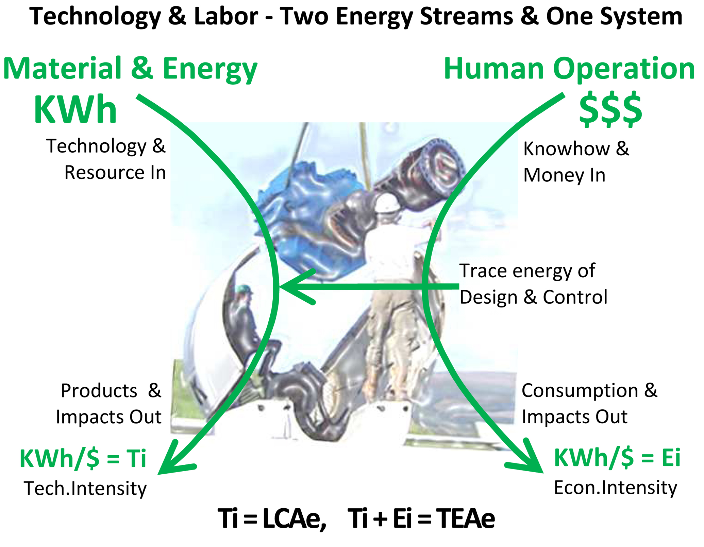

Fig. 1 - Assembling A Wind Turbine, Two Men and a Crane; Connecting Mechanical and Human Energy services. The energy and resource streams that power each are counted as part of the system of work and use. The two streams are largely separate, in that you can't sell what you consume or consume what you're going to sell, so estimates of each are added to get the total.



**Figure Energy Intensity.** Include such a graph IF (1) we have room in the end, and (2) if we create our own graph from baseline data (US EIA or the IEA) and make the values in the graph correspond to our equations presented in this section.



**Figure Energy Flow.** The annual flow of energy consumed (negative) and produced (positive) is very similar for all levels of analysis after the first year when there is a large negative energy flow for manufacturing, constructing, and purchasing the turbine technology.