Systems-thinking + Systems-making

Joining systems thought and systems action
J.L. Henshaw HDS natural systems design science,
680 Ft. Washington Ave. New York NY 10040
www.synapse9.com eco@synapse9.com 212-795-4844
Abstract: This paper collects recent inquiries into “systems-thinking” and “systems-making”. The first I see as a practice of developing explanatory systems of ideas somewhat separate from any applications. The second I see as a practice of improvising, developing the theory and material aspects of designs together, bringing theory and nature closer together. They differ as paradigms of thinking, one centered on fitting mental images together, the other on fitting material relationships together, mental design versus material design. Patterns of their differences and similarities are discussed while looking for how each can work with the other. Both strategies have much in common. They both tend to 1) proceed by nonlinear step-wise accumulative inquiries and 2) end in designs with emergent properties, and also 3) rely on the use of natural language to communicate specialized terms of art. Like all sciences they also both 4) rely on relating to nature by observing and testing as if in conversation, translating back and forth, as depicted in the model proposed by Robert Rosen (1991). Studying those differing processes and how they work helps expose opportunity for their working more successfully apart and together.
keywords: systems-thinking, systems-making, learning, design, complexity, natural language, action research, pattern-language
Contents
I. Systems Science Context 2
A. Introduction 2

B. Separate Cultures, Common Strategies 4
C. “Action Research” Structured Learning. 5
D. Patterns of Scientific Systems-Thinking. 7
E Patterns of Scientific System-Making 9

II. Combined Models and Methods 12
A. Alexander’s System-Making Template 12
B. ST & SM Guides I Common Design Tasks 13
C. ST & SM Guides II System in Environment

IV. Conclusions 17
V. Acknowledgements 17
VI. Bio 18
VII. References 18

- Systems Science Context

Introduction
This research paper pulls together recent threads of inquiry into the practices of “systems-thinking”(ST) and “systems-making”(SM), how they differ and connect. The distinction in emphasis is that one is primarily concerned with making mental models (as systems of thought) and the other primarily concerned with creating material designs and organization. A strong focus on one without the other would be unbalanced. A strong focus on both, alternating to work together, is more the ideal (Figure 1). As in Figure 1 one would expect system ideas to emerge in any of the four quadrants, with the normal practice to follow an exploratory path ending up “converging” with others on what is in some way holistically practical.
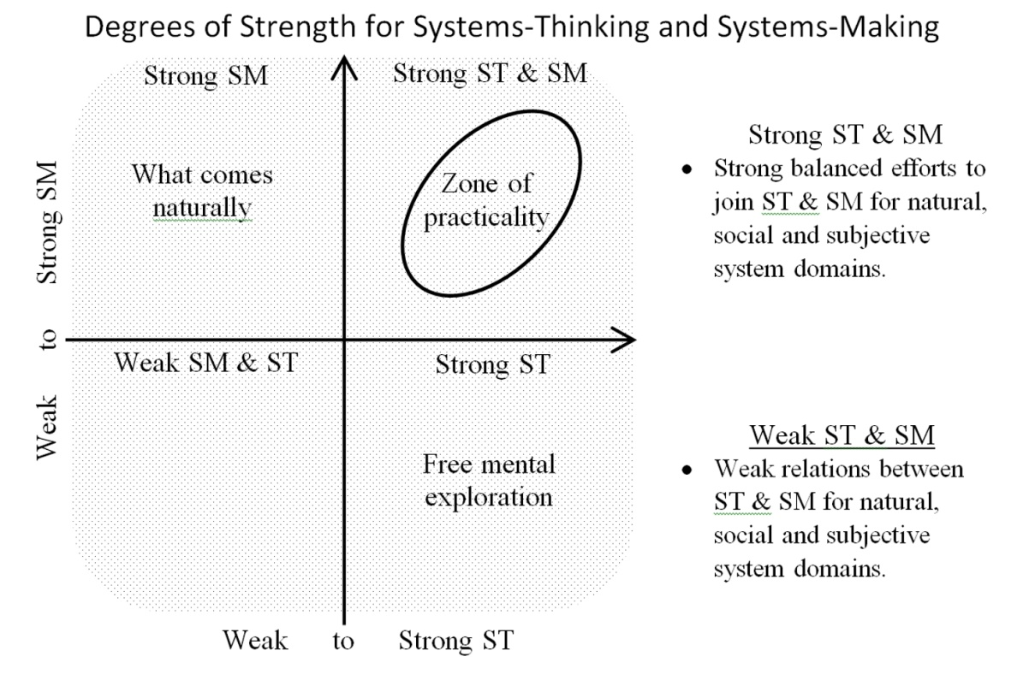
- Strong and Weak “Systems-Thinking” and “Systems-Making”
My interpretation of complex systems is somewhat like that of Midgley (1992, 2016), who recognized the need for a plurality of competing paradigms, for “natural world”, “societal world”, “subjective world” worldviews and “their interactions”. I go a bit further, based on evidence that people develop worldviews like languages, and readily shift from one and another for those they know. That’s visible in how we readily switch between worldviews for differing circumstances, and for different professional, family and personal social networks. I think the minimum number of four paradigms somewhat overlooks the multiplicity of different competing paradigms people need to recognize to get along. In my papers on natural system pattern language (Henshaw 2015a, 2015b) I refer to this need for recognizing multiple paradigms as a “dual-paradigm” view. It treats as the minimum duality of worldviews as being “natural world” and “interpretive”. In this paper I’m repositioning those issues under the paradigms of ST and SM, with ST being centered on making explanations and SM centered on making.
The balance needed between SM and ST is in their interactions and each one’s coupling with the natural world. How our minds explain things conceptually will often need to ignore natural processes that will need to take place developmentally. Conversely, a focus on how things can develop practically can be out of balance with and lose sight of broader conceptual designs and goals. To keep differing paradigms in balance the focus usually needs to go back and forth, working on bridges between them, each serving as a guide for the other (see also Figure 2 & 3). I see this work as in keeping with the increasingly common practice of using systems-thinking and systems-making in alternation (Ison, 2008). My thesis is that as we learn to work with complex systems the forces in our environment increasingly seem to be pushing us to clarify the separate roles of systems-thinking and systems-making so they can better work together. To coordinate each often needs to proceed by itself. Each will also sometimes need to take the lead or hold back and sometimes need to back-track and start over as the other is put on hold to work effectively together, a marriage of opposites that needs to be in balance.
The importance of each being able to remain independent comes from each being a process of organizational development, needing successive additions that fit together with the elements being built onto, and those it will follow. How the parts making a house fit together is a good example. How a house is made starts with removing what was there before, then digging holes for the foundations, to then pour or lay the foundations, so you can then start building floors and walls till you can put the roof on and start installing the interiors and finishes. It’s only at that point that the work of creating the “new way of living” the house was made for can begin. That each step can coordinate with the next is all-important.

The word “growth” also generally refers to long process of fitting together steps of connecting change following an accumulative sequence. Nature uses it to develop new living systems and eruptions of many kinds. People use it to grow their cultures and communities, their businesses and the world economy. We also grow our ways of system-thinking by fitting mental images together and grow our system-making by finding the right material changes to go together too. We also use personal growth to overcome challenges in school and life to rise to the occasion. Generally what succeeds is a chain of fitting steps that build on each other.
I mention that both to suggest the variety of kinds of growth processes that systems-thinking and systems-making might address. I also mention it to point out the shared language that may be available for discussing growth of their own and other kinds from each different view. Growth of many kinds creates a home for what’s inside them too. Recognizing that offers a potential bridge between knowledge silos that seem to have so little in common they are unable to communicate.

Separate Cultures, Common Strategies
The theoretical biologist Robert Rosen pointed out various discrepancies between scientific theory and evident patterns of systems-making in nature (1991). Rosen’s approach bucked the common assumption in the sciences that the laws of science are embedded in nature. His model of science depicts it more as a conversation with nature, the theories of science being human translations from observed patterns in nature. It makes little difference for the scientific validity of natural laws, but makes a big difference for understanding the relationships between sciences and with other ways of interpreting nature, as depicted in Figure 2.
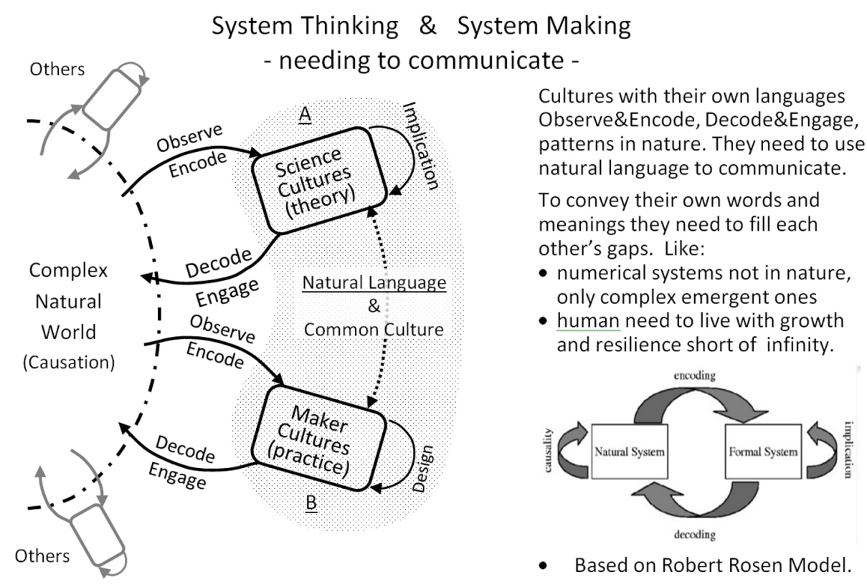
- Systems Thinking & Systems Making only connected by common language.
In Figure 2, “Scientific Cultures” and “Maker Cultures” are depicted as in Rosen’s model, turning their attention back and forth between nature and their internal processes, “theory & implication” for the sciences, “practice & design” for crafts. Each looks for patterns in nature their methods can reliably “observe and encode”. Each also looks for effective ways to apply their “implications” or “designs” and “decode and engage” with nature. Each kind of knowledge is fairly isolated from each other, and each loses different things in translating back and forth between the patterns of their internal and external subjects. The implication is that each also would be finding important insights into nature that fit its own specialized form of knowledge, that it can’t directly share with others in their own specialized form of knowledge.
T. S. Kuhn (1970) addressed part of the communication problem this creates, discussing the failure of emerging scientific paradigms to gain converts. That requires any new paradigm to gain a toe hole somewhere and then grow to replace the old paradigm, displacing rather than converting the latter’s adherents. It appears the rigidity of natural ways of thinking creates silos of culture that can’t change, and we are in a world of ever faster change that needs them to.
As in Figure 2, for differing whole cultures that develop their paradigms of thought side-by-side paradigm succession, however difficult, can only work internally. To learn from each other it is implied that each culture might find bridges between their languages, and convey their new ideas using their shared natural language, using cultural transmission not replacement. One place such transmission seems possible is for new learning methods each is developing as each faces the growing challenges of our complex world. Even if only in a modest way it might be a tremendous breakthrough.

“Action Research” Model Structured Learning
All learning really follows a process of turning attention back and forth between subjects, not so different from the Rosen model of scientific learning. Figure 3 shows a depiction of the learning practice called “action research” or sometimes “action learning’, as alternating periods of work and pauses for discussing the work (Stephens et all. 2009; Flood 2010; Ison 2008; Jackson2003; Reason & Bradbury 2001; Susman & Evered 1978; Lewin 1947) . It’s an ancient practice for designers like architects now increasingly is used for business management, software development and other design practices. It is being done much more self-consciously, described as transformational, and suggested as a sources of deep cultural knowledge for systematic environmental engagement to learn from. A very similar approach is called One of the leading practices is called the “Agile method” and “SCRUM” as action research for highly productive teamwork (Rising, & Janoff 2000; Schwaber 1997, 2004).

What is seems to be driving it is partly the scale of business organizations and intensity of competition, partly progress is the social sciences of the organization. Partly seems o be also that sustainability and complex regulation require far more disciplined innovation, making everyone become more of a designer. As profitable innovation in basic learning strategies creates a demand around the world that might let them spread widely. Figure 3 shows a very conceptual diagram arranged to reflect the work of a design team that alternates between periods of work and review. The circles represent the breaks in the work for study of all dimensions of the project’s progress and requirements and for setting clear goals for the next phase of work. The arrows are the stages of concentrated work on the new direction, ending in a presentation of all aspects to start the next stage for review and study.
You can see that same basic pattern of alternating work and review in many kinds of familiar practices as well, looking up at the end of each stage of work, suggesting it has been a natural pattern that has been with us throughout human history. What has changed over time is the vastly improved knowledge and tools and methods of learning that have become increasingly purposeful and sophisticated.
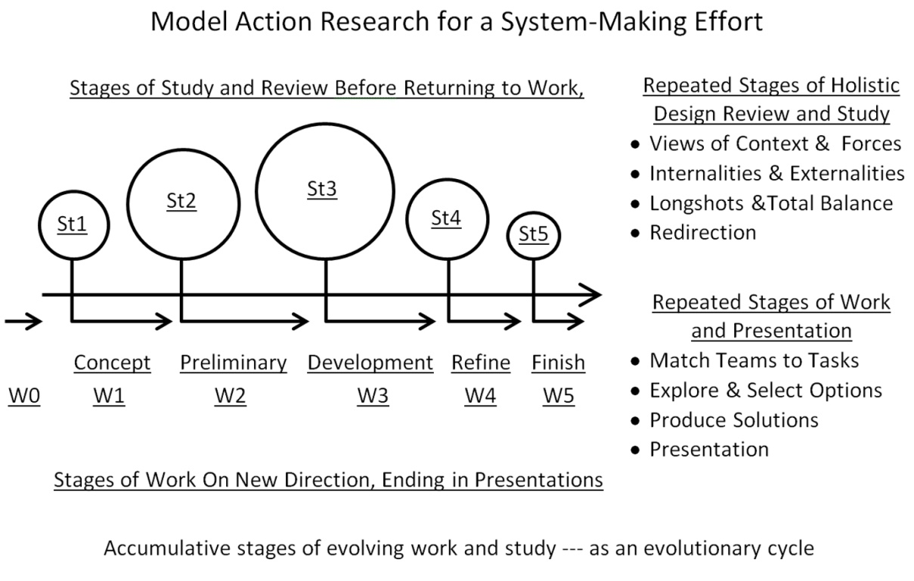

- A general design for complex system learning.

We see the shape of action learning the natural strategy we commonly use for “making lunch”, displaying how we exhibit our own expertise, improvising from step to step as we go to. We also see the design of sophisticated sequential design and learning in long term processes of education by repeated periods of work and reflection or in the complex business methods of “creating a product”, going through many steps with contributions from diverse teams of specialists all making their independent contributions, improvising as they go. Those stepwise learning methods can also be recognized from the succession in scales of the steps:
- first proceeding by smaller tentative steps,
- then building up usually in a non-linear way toward taking larger bold steps,
- only to similarly reverse course to scale down in a non-linear way
- toward smaller finishing steps that break off at completion.
That heuristic, marked by a continuity of usually non-linear rising and falling scale steps, is often recognizable by surrounding observers without direct involvement. That makes it a mark of where one can look to study what creative learning happening nearby. It could also be an opening for learning and sharing action research methods. If they are made explicit innovation in learning methods of fields normally work in closed silos might bridge those barriers, making them part of the common language of design.

Patterns of Scientific Systems-Thinking.
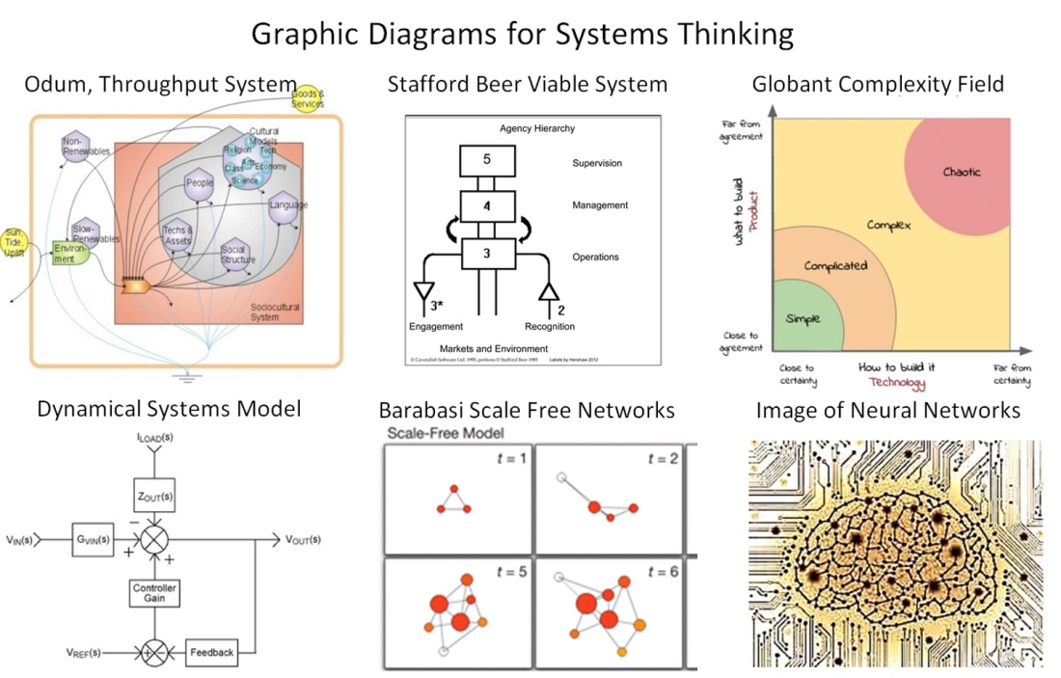
- Systems-Thinking Concept Diagrams
Today’s mainstream systems science most directly came from the abstract theoretical work the 1940’s and 50’s on cybernetic and information theories of Weiner (1948), Von Bertalanffy (1969) and Ashby (1956). A great variety of others took directions that built on or branched off from those founders. Economists like Ken Boulding (1956) had great influence too, bringing with them the use of economic models on which other kinds of theoretical models were based. The origins of the modern science of “complexity” came from the later discoveries in the physics of irreversible thermodynamics investigated by Prigogine Nicolis & Prigogine (1967) and others. A further advance came from the recognition by Georgescu-Roegen (1971) that the entropy principle of thermodynamics also applies to modeling the use of natural resources. Another pivotal advance in theoretical systems science was the use of computer modeling of equations for chaotic fluctuation (Feigenbaum et all. 1982), in combination creating a new abstract theoretical world view just called “Complexity”. (See also Henshaw (2010a) for more on how the diverse branches of the systems sciences developed and on important questions that remain unanswered).
More recent innovation in complex systems science has been more about computer applications with advances in modeling Complex Adaptive Systems (CAS) (Gel-Man 1993; Holland 1992; Bar-Yam 1997). Those all set the stage for the modeling “artificial life” using cellular automata and “artificial intelligence”, for which current advances are almost too numerous to characterize (Langton 1989; Russell et all. 2003). A general view by Goerner (1999) of “After the Clockwork Universe” summarizes the new view of the complex world we live in that these combined developments created. This advanced science of complexity can also be applied to business decision making as by Kurtz & Snowden’s (2003) Cynefin sense making method. A Google Ngram for complexity terms (Figure 4a) shows the frequency of these terms of complexity science in books scanned by Google, perhaps suggesting a slowing growth and rate of new emerging disciplines.
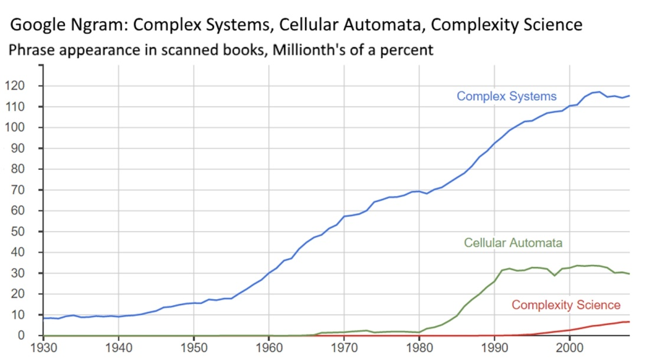
Figure 4a Complex Systems, Cellular Automata, Complexity Science Ngram
Less known earlier scientists with quite important contributions are were the early economists Jevons (1872, 1885) and Keynes (1935). Their highly useful findings were not derived from abstract theory, but developed from observation, of the workings of economies they observed and from reasoning of how businesses and societies really work. My view is that some of their neglected findings would be important to today’s complex systems science and easily validated, but remain neglected for not having been derived from abstract theoretical methods. Keynes, for example, noted that compound financial investment would need to end for the economy to stabilize at its limits to growth (ch 16; Keynes 1935; Boulding 1962), and Jevons observed that improving resource use efficiency generally accelerated not decelerated their rates of depletion (Jevons 1885; Polimeni 2008).
Developments in ecology also contributed to advanced systems-thinking, ecologists like Odum (1983) and Gunderson & Holling (2001) are best known to systems sciences for their ways of representing natural systems with computer models. They modeled ecologies as economies of nature, adding evolutionary variables for representing ecologies as learning systems. Today the focus of interest in ecology has turned for evident reason to the complex conditions of ecological distress; understanding the complex system property called “resilience” by Walker & Holling (2004) among many others. Others such as Ulanowitz (2009) take a more analytical approach, demonstrating an increasing pressure on ecosystems results in an inverse relationship between efficiency and resilience, with clear natural limits.

Patterns of Scientific System-Making

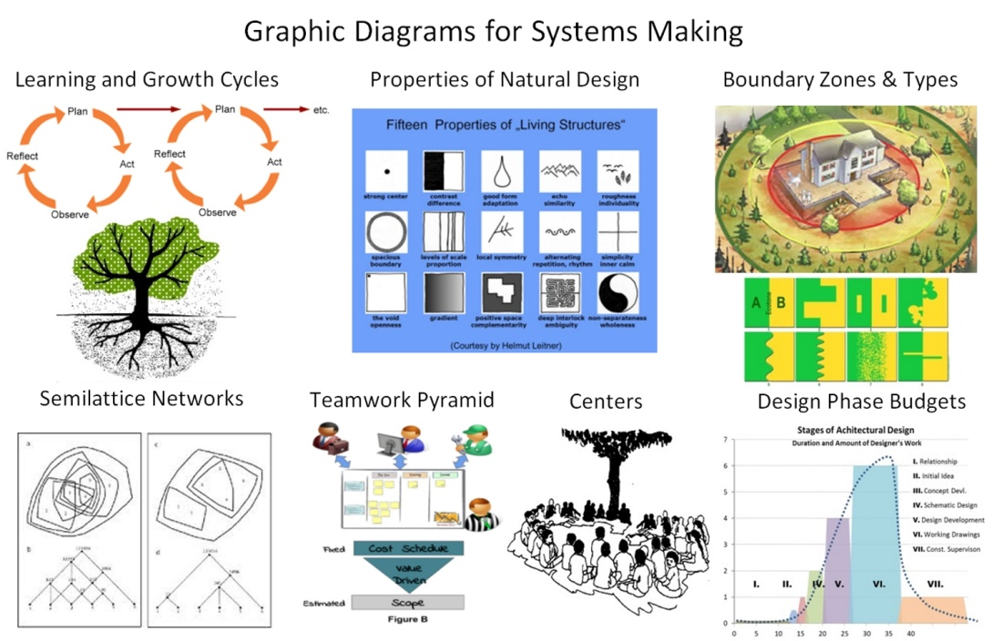
- System Making Concept Diagrams
Scientific practice and theory for making and guiding complexly organized systems developed somewhat parallel to the abstract sciences of complex systems. The use of “action research” as a organizing tool emerged in the 1940’s with Lewin’s group dynamics (1947). Growing interest in the social and business management sciences to faced with an ever more complex world for decision making drove its development and kept it separate from the abstract systems sciences. Churchman in (1979) began emphasizing terms of natural language for discussing organizations (rather than abstract theory). Checkland then proposed (1981) a “soft systems methodology” (SSM). Together that made a clean break from the “hard sciences” and the systems engineering approach that had proceeded (Susman & Evered 1978; Reason & Bradbury 2001; Senge 2006; Jackson2003, 2007; Ison 2008; Stephens et all. 2009; Flood 2010; Checkland & Poulter 2010, 2014).
These movements are somewhat harder to trace than for the hard sciences for seeming natural cause. They don’t have the press attention the hard sciences have for one. They are also centered more on “hands on” methods of creative collaboration, passed down more as “practices” than theories, and so not fully recorded in research papers. Their terms of discussion are sometimes less consistent, such as with a new term “action learning” (McGill & Brockbank 2003) which has become hard to clearly distinguish in practice. Recent important developments include the emergence of Agile Management (Schwaber 1997, 2004) and the associated SCRUM method of business team-learning widely adopted for software development and creative business management.
Another important innovation stretches the envelope of action-research, called “pattern language”. It is a more content based collaborative method of holistic architectural design, invented in the 70’s by Christopher Alexander (Alexander 1965, 1977, 1979) and spread widely to other fields in the 80’s and 90’s (Tidwell 1999; Rising 2000; Pugh 1991; Hillside Group 1993-2017). Its importance is partly its revolutionary conception and partly its ability to spread a high level design language from one field to another. That ability to spread comes from its origin as a technique for making ancient practices of holistic design explicit, so people could copy them, a general model of recording expert knowledge.
Pattern language is also an action research kind of creative method when applied to any field of creative design. Its early form developed from Alexander’s teaching architectural theory at Berkeley and writing his first book “A Pattern Language”(1977) as an explicit method. It’s use enabled the development of modern “object oriented” software in the 80’s. It provided much of the theoretical foundation enabling the development of Wiki’s and leading to Wikipedia (Gamma et all. 1995; Leitner 2016). Being organized around as way to explicitly record reusable holistic design ‘patterns’ seems to be what is so successful in helping designers better understand the opportunities and requirements of their designs.
The Google Ngram below (Figure 5a) shows the frequency of “action research”, “action learning” and “pattern language” in many books scanned by Google, showing the pace and timing of those emerging system-making disciplines, showing sine continuing rapid growth.
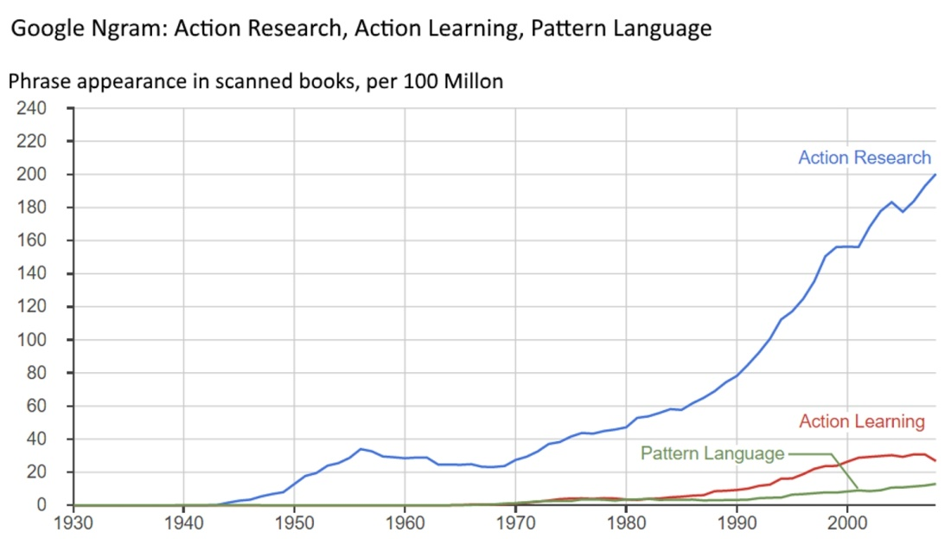
Figure 5a Ngram for Action Research & Action Learning
My own approach to systems science is a mixture of system-thinking and system-making. It came from field research in physics that exposed some of the system-making processes of common air currents. That study traced the evolution of indoor convection currents over 24 hour cycles in passive buildings, watching as their shapes and pathways evolved individually and with the motion of the sun in the course of a day. It let me closely study complexly organized energy systems emerging and changing in form over their lifetimes (Henshaw 1978). They were also notable for displaying predictable patterns of non-linear development that matched their organizational changes. It was that ability to locate their system boundaries in time and space and correlate them with non-linear phases in changing organization that prompted a general systems theory of system-making.
It’s having those orthogonal views grounded in physics and observation that led to my scientific systems-thinking about system-making (Henshaw 1979, 1985). Those boundaries let one interpret natural systems as a “black box” for testing hypotheses and looking for how internal processes and external relationships are both separated and connected. As a body of work, my writings focus mainly on complex systems behaving as exploratory systems, either having or acting like they have actively learning parts. Those include ecologies, economies and others things that develop by innovation and growth (1979, 2008 2010b 2011, 2015a, 2015b, 2010c). That led to learning to recognize more and more kinds of accumulative non-linear organizational change as markers of the organizational change in dynamic systems like cultural eruptions, collapses and flocking behavior as markets chased after bargains or fled from threats..
- Methods

Alexander’s System-Making Template
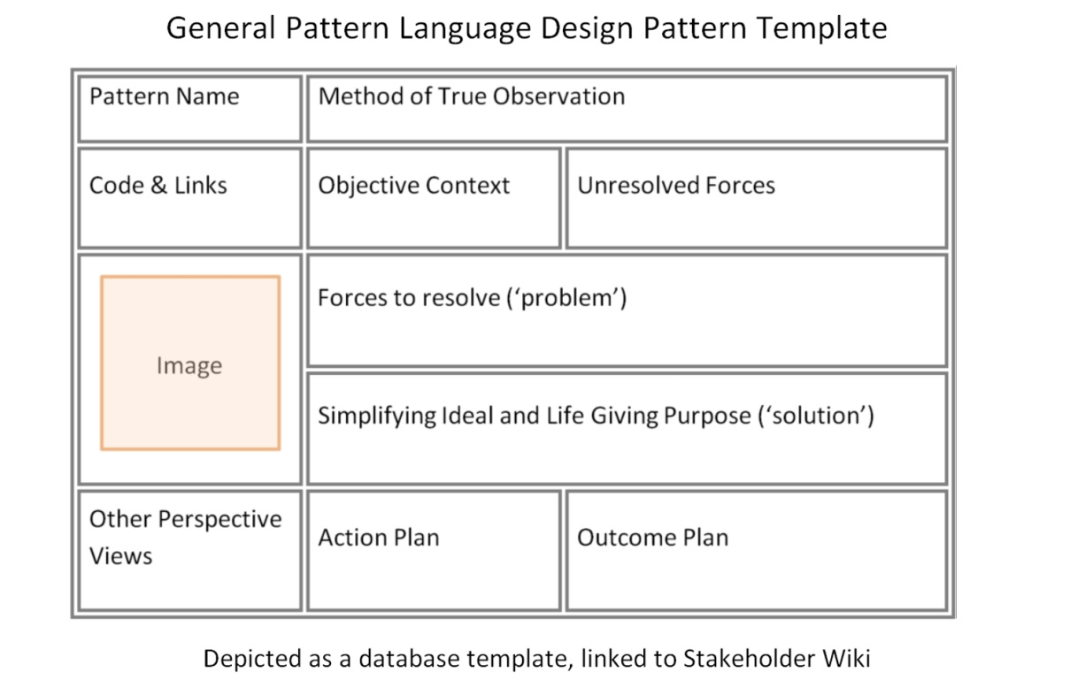
- Template for Explicit Holistic Design Pattern Writing
What is most unusual about Alexander’s language of holistic design is its ability to flourish while passing from one community to another. Part of what makes that possible is using a structured learning template like in Figure 6. It pulls a user in several holistic learning directions at once, ones he described in his book “The Timeless Way of Building” (Alexander 1979, Iba 2014). The template fosters a holistic approach, intended to condense the essentials of expert knowledge recurrent circumstances. The template asks a set of challenging orthogonal questions to answer, that are aimed guiding the user to follow the ancient ideals of architectural design.
The structured learning produced is a “design pattern” for a simplifying ideal way to respond to the identified “forces”, exhibiting “emergent properties” that creating strong “centers” of “living quality” (Alexander 1979). Speaking of its use for software development, Jennifer Tidwell (1999) touches on the heart of why this method makes that possible:
“They are not abstract principles that require you to rediscover how to apply them successfully, nor are they overly specific to one particular situation or culture. Instead, they are somewhere in-between: a pattern describes possible good solutions to a common design problem within a certain context, by describing the invariant qualities of all those solutions.”
My recent papers on the pattern language (Henshaw 2015a 2015b) contain a variety of references and supplemental resources.
A “home” is such a universal “ideal expert solution”, composed of an enclosure with openings allowing its occupants a secure domain. It’s where they can define their own way of living, having ready access to the networks of the exterior world. A “currency” is another ideal expert solution fraught with sometimes great risk. Money is a common token of value that each holder assigns their own value to in trade with others, so normally every exchange is profitable to both. It’s the potency of these powerful designs makes them important to study as “patterns” and how they affect the world around them. So part of the ST involved in using Alexander’s technique of SM is learning how to recognize these neat packages of design elements and their powerful emergent effects.
Filling in the blanks in a blank template is what guides a designer to study their contexts for unresolved forces as part of the search for simplifying ideals for resolving them. As with any design process you don’t automatically know what design elements you’ll need to weave together. You first start with a “blank template” and are guided to explore holistic views of multiple kinds, always prompting you to look beyond the horizons. At first it’s an open ended effort of “problem finding“ which then sets idealistically practical standards for “solution finding”. With each kind of search you’d ask recurrent questions for different views;
- for the internal and external relationships of systems studied,
- for the independence and connections of the parts,
- for searching their natural world, societal and subjective relationships.
- for both the subjects as they exist and as they are interpreted.
- Perhaps as great a value as the method is
the suggestion that designers have apparently been doing this kind of thinking since the dawn of civilization, only passing it down non-verbally. How this kind of design template would be used for action-research is as depicted in Figure 3, starting with a blank template. Each cycle of accumulating work and study would revisit the same searching questions from the new vantage point, moving toward the fulfilling ideal for both the SM and ST in the end. Seeking balance and life-giving qualities as explicit ideals, the structured learning becomes a “scientific method” of holistic design.

ST & SM Guides I – Common Design Tasks
Figure 7 depicts two very general systems-thinking guides for system-making. The first guide (7.1) symbolizes the rising and then falling complexity of efforts for starting and completing any task, an “inside view” of it. The second (7.2) shows the accelerating and decelerating accumulating use of energy and other resources in the process. Both have beginning (A) and ending (B) periods for the respective “build-up” and “build-down” phases. To use these guides you just need to think through the kinds of decision making involved in guiding familiar projects from beginning to end. Take “making lunch” for example. It’s usually an improvisational design task that starts with an idea and then proceeds with refining a concept as you put together the end product, a course of creative effort with a clear beginning and end, following these classical patterns (7.1,7.2).

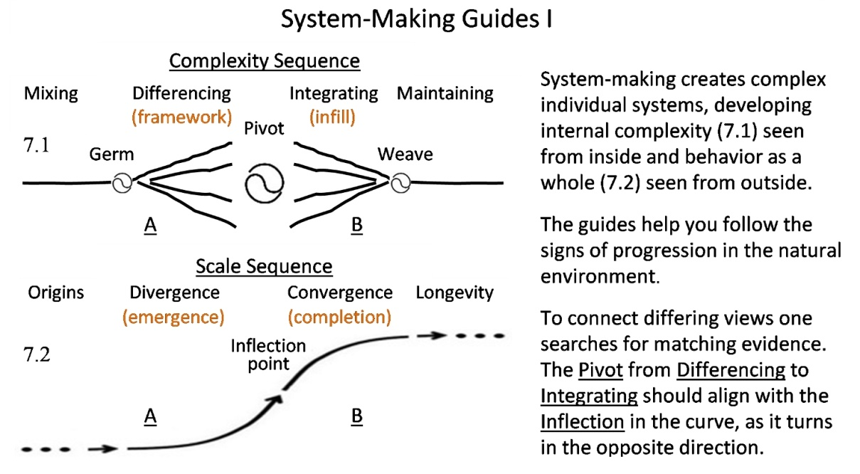
- Process Diagrams for System-Making
To go through the steps think of “making lunch” as a repetitive process of innovation, a series of steps as your attention turns back and forth between the concept and the process again and again. It might starting from opening the fridge to get out the main ingredients, collecting the needed dishes and utensils, and thinking through the appetites that need to be satisfied. That initial stage sets up the framework for the work, getting everything ready to combine. That “differentiates” the ingredients by task, expanding the complexity of the work by increasing steps at first. That increasing complexity then “pivots” toward reducing it again, as the framework is filled in with the large then successively smaller details “integration”. As that nears completion the final touches added are to “weave” the product into the environment in which it needs to fit in with, to achieve a satisfying balance and full service in the end.
This normal way people go about improvising familiar design tasks, going back and forth between ST on the intent and SM putting the pieces together is the normal natural practice our leaning reinforces. That “intuitive way” is what more formal “action research” projects are based on. Generally formal plans would include all the parts of (7.1 & 7.2) as the most general case. For both simple and complex projects an outside observer will be less able to follow the expanding and contracting complexity of the internal process. That observer will be more aware of the rising and falling scale of change and its constraints (7.2), than the people absorbed in the details, as differences in exposure, each view having different things seen more clearly and hidden from it.
Other examples that can be studied this way include 1) designing a home 2) going through a grade level in school and 3) how we respond to emergencies. Many natural processes follow the same pattern too, though our terminology for them may differ, such as 4) biological reproduction from fertilization to birth, or from birth to maturity and 5) the growth of civilizations from their “early renaissance” to their “classical periods”. What the various whole system diagrams do is provide an easy way of holding together whole narratives of complex accumulative designs, connecting the “inside view” (7.1) and “outside view” (7.2) proceeding in a familiar way.
beginning (A) and ending (B) periods for the respective “build-up” and “build-down”
The beginning and ending stages (A) & (B) of increasing and decreasing complexity (7.1) generally do correspond to the respective stages (A) and (B) of accelerating and decelerating increase in scale (7.2). They are given different names to associate them with the observer’s view. Seeing evidence from view will often help you find corresponding evidence in the other, like how a “plan view” of a building is very different from an aerial view, each showing the same building. So very importantly, one can quite often confirm a finding of one kind with evidence of the other. The stages of each kind of development may vary quite widely, of course.
All three of the major turning points in the accumulating complexity (7.1), the ‘germ’, ‘pivot’ and ‘weave’ as points of change, occur at times when very little may seem to be changing. Looking from the outside view (7.2) tracing the scale of accumulating work, offer little hint of internal complexities that are changing, not even at the “inflection” point in the middle where the turn from expanding of filling in the system’s complex framework changes. For “making lunch” the final touches of putting the food into the lunch box or onto the table generally make big differences in presentation and in how much the meal will be enjoyed. Without prompting to study the plurality of world views one might well overlook that meals are also social ceremonies, even if done for one’s self, and that greater purpose is often present in the initiating ‘germ’ of any process if you look just a little closer.

ST & SM Guide II – System in Environment
We can also look at the same progressions (Figure 8) depicted as a developing organization in its environment. The corresponding type (A) stage (8.1) is shown as a block of operations with Self-Investment driving its growth. That becomes a Self-maintenance core of the organization when in (8.2) when the added Life-Investment stage is added on. This simplifies the general growth model of businesses, while keeping the differentiation of the core functions and environmental interface. The actual subject could be organism or a business or a person and their life’s work, for distinguishing the core and interface parts. For a family business the “pivot” point is when it has adequately established itself and attention can turn to living well instead of putting every resource and effort to into the business to get it to grow. Resources are then available to expand their savings for the future and enjoyment.

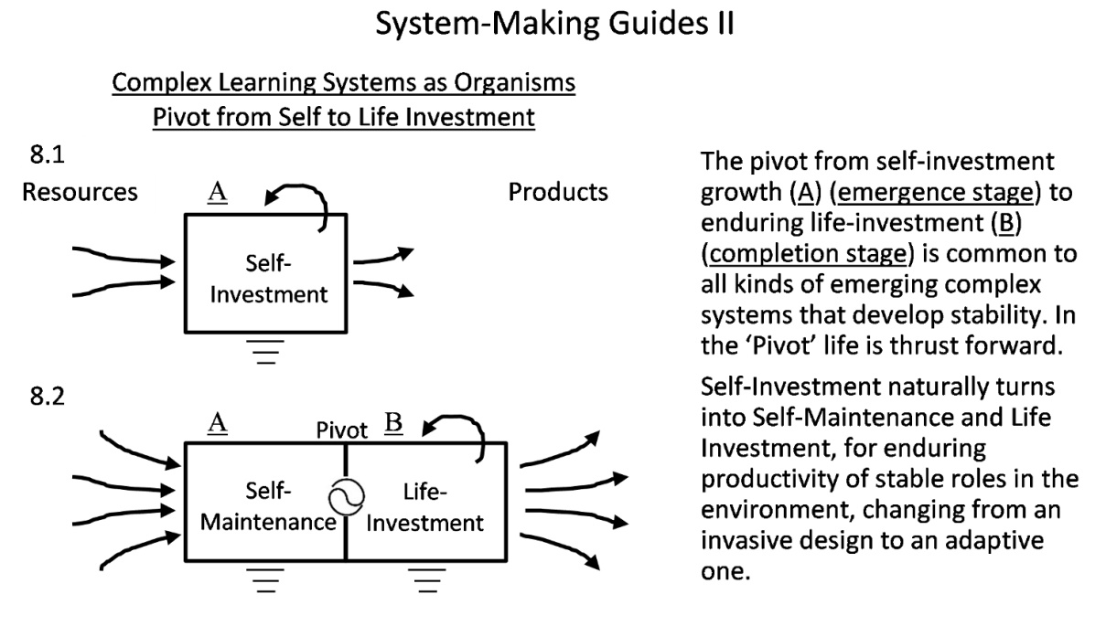
- Organization Phase Diagrams for Systems Making

As these life-cycle patterns become familiar the main test of validity will be the feedback of accumulative useful learning itself. Using the more structured methods (like Figure 3) for repeatedly exploring all the options, as with a learning template like Alexander’s (Figure 6), is designed to be self-critical and objective. So a well-constructed action research produces satisfying results that’s a positive feedback for the direction taken as well. This natural self-validation of a system-making process is no guarantee the whole approach isn’t unbalanced, though, and other kinds of evaluation are needed.
One broad method of evaluating systemic interventions is given by Midgley (2007). It can be difficult to know what criteria to use for measuring the success of multi-stakeholder action-research projects in particular. The differing views of the stakeholders will suggest different criteria, and the evaluation may come at the end be more biased. That dilemma is somewhat resolved by just broadening the view, so an outsider to the process can ask the questions, assessing the overall fitness of the project for the circumstance on three dimensions. The basic goal is to assess the project as a whole for fitness and balance of its own parts, asking whether it was well suited for 1) the circumstance, 2) for the abilities of the team involved, and also 3) for the purpose intended. Additional fitness indicators could also be added, such as having “emergent properties” or producing “living quality” in the result, as pattern language designs are intended to have. The value of the approach is partly that of getting to judge the project using criteria different from those used in doing it. It directly addresses a common problem with action research efforts, that of doing one thing quite well and others somewhat poorly, so falling short addressing the subject as a whole.

- Conclusion
TBD

- Acknowledgements
Thanks go to Helmut Leitner and Gerald Midgley for useful suggestions and for the freedom I’ve had to do the work.
- Bio
Jessie. Henshaw’s innovative systems science goes back to the 1970’s. Her degrees are in physics and architecture. Having been taught to learn from observation let her notice the strong similarity of life-cycle patterns of natural and human designs complex accumulative design of both natural and human systems sources. Her initial field research on natural system energy use was of how convection develops and subsides over 24 hour periods within houses. The main finding was the particularly clear connection of stages of non-linear energy use with non-linear progressions in emerging system-making in the forms of air currents and their pathways. From that her body of physics and natural system design research developed for recognizing and narrating observed non-liner dynamics and emerging phases of organizational change for human and natural systems. Jessie presently lives in New York City. She has a B.S in physics from St. Lawrence University, post-graduate study in mathematics and architecture from Stony Brook and then Columbia Univ., a masters in environmental design from the Univ. of Pennsylvania, and her extensive body of research. She does consulting, research and writing as HDS natural systems design science.
Links: Research Journal - “Reading Nature’s Signals” http://synapse9.com/signals,
Jessie Henshaw Publication List http://synapse9.com/jlhpub.htm
- References

Ashby, W. R. (1956). An introduction to cybernetics. An introduction to cybernetics. ISBN 1-614-27765-6.
Ashby W.R. (1958) Requisite variety and its implications for the control of complex systems. Cybernetica, 1:2, p. 83-99. ISSN 0011-4227Retrieved from - http://pcp.vub.ac.be/Books/AshbyReqVar.pdf
Alexander C. (1965) A city is not a Tree. Architectural Forum, , Vol 122, No 1, April 1965, pp 58-62 (Part I),Vol 122, No 2, May 1965, pp 58-62 (Part II). ISSN 0003-8539. Retrieved from -http://library.uniteddiversity.coop/Ecological_Building/The_Timeless_Way_of_Building_Complete.pdf

Alexander, C., Ishikawa, S., Silverstein, M., Jacobson, M., Fiksdahl-King, I., Angel, S. (1977). A Pattern Language. New York: Oxford University Press. ISBN 0-195-01919-9.
Alexander, C., (1979). The Timeless Way of Building. New York: Oxford University Press. ISBN 0-195-02402-9. Retrieved from -https://en.wikipedia.org/wiki/The_Timeless_Way_of_Building
Bar-Yam, Y.(1997) Dynamics of Complex Systems. Westview Press. ISBN 0-201-55748-7.

Boulding, K. E. (1956). General systems theory-the skeleton of science. Management science, 2(3), 197-208. ISSN 5-6490-4123.
Boulding, K. E.(1962) A Reconstruction of Economics: Kenneth Boulding. John Wiley Science Editions, Ch 17 The future of capitalism. ISBN 1-484-17043-0.

Checkland, P. (1981). Systems thinking, systems practice. John Wiley and Sons, New York, New York. ISBN 2-516-53494.
Checkland, P., & Poulter, J. (2010). Soft systems methodology. In Systems approaches to managing change: A practical guide (pp. 191-242). Springer London. ISBN 1-9495-7013.
Churchman, C. W. (1979). The systems approach and its enemies. Basic Books. ISBN 1-484-17062-0.
Feigenbaum, M. J., Kadanoff, L. P., & Shenker, S. J. (1982). Quasiperiodicity in dissipative systems: a renormalization group analysis. Physica D: Nonlinear Phenomena, 5(2), 370-386.669. ISSN 0167-2789.

Flood, R. L. (2010). The relationship of ‘systems thinking’to action research. Systemic Practice and Action Research, 23(4), 269-284. ISBN 1-484-17676-1.
Gamma, E., Helm, R., Johnson, R., Vlissides, J. (1995). Design Patterns: elements of reusable object-oriented software. Pearson Education. ISBN 311-71684.
Gell-Mann, M. (1994). Complex adaptive systems. in Complexity: Metaphors, Models, and Reality Eds. G. Cowan, D. Pines, and D. Meltzer, SFI Studies in the Sciences of Complexity, Proc. Vol. XIX, Addison-Wesley. ISBN 301-58141.
Georgescu-Roegen, N. (1993). The law of entropy and the economic process. Cambridge, MA, USA: Harvard University Press. ISBN 1-4841-70739.

Goerner, S.J., 1999. After the Clockwork Universe: The Emerging Science and Culture of integral society. Edinburgh : Floris Books. ISBN 1-484-17080-7
.
Gunderson, L. H., Holling, C.S. (2001). Panarchy: understanding transformations in human and natural systems. Island press. ISBN 1-559-63857-5.
Henshaw, P. (1978) Natural Orders in Convection. Self-published with partial support from the International Solar Energy Society. Retrieved from - http://www.synapse9.com/pub/1978_NatOrdersConv-Henshaw.pdf
Henshaw, P. (1979). An unhidden Pattern of Events. republished 2014 in An Open Source Pattern Language, “Patterns of Complex Natural Systems” by H. Finidori. Originally in book of same name, self-published edition, Denver 1979. Retrieved from - http://debategraph.org/Details.aspx?nid=360233
Henshaw, P. (1985) Directed Opportunity, Directed Impetus: New tools for investigating autonomous causation, Society for General Systems Research, Louisville KY. ISBN 0-914-10536-1. Retrieved from - http://www.synapse9.com/pub/1985_DirOpp.pdf
Henshaw, P. (2008) Life’s Hidden Resources for Learning, Cosmos & History: The Journal of Natural and Social Philosophy, vol. 4, nos. 1-2, 2008, 2008 issue on "What is Life". ISSN 1832-9101. Retrieved from - http://www.cosmosandhistory.org/index.php/journal/article/view/102/203
Henshaw, P. (2010-a). Complex Systems, Encyclopedia of the Earth. ISSN: 0950-4125. Retrieved from - http://editors.eol.org/eoearth/wiki/Complex_Systems
Henshaw, P. (2010 b). Models Learning Change. Cosmos and History, ISSN 1832-9101, 6(1). Retrieved from - http://www.cosmosandhistory.org/index.php/journal/article/view/176/295
Henshaw, P. (2010 c) The Energy Physics of Continuity in Change . Introduction to the 1995 theorem, Draft. Online - http://www.synapse9.com/drafts/LawOfContinuity.pdf
Henshaw, P., King, C., Zarmolsi, J. (2011) System Energy Assessment (SEA), Defining a Standard Measure of EROI for Energy Businesses as Whole Systems. Sustainability 2011, 3(10), 1908-1943; doi:10.3390/su3101908 ISSN 2071-1050.
Henshaw, J. (2015 a) Guiding Patterns of Naturally Occurring Design: Elements, in Proceedings PURPLSOC 2015 “Pursuit of Pattern Languages for Societal Change” , July 3-5 2015 Krems, Austria. ISBN 9-646-73066. Retrieved from - http://www.synapse9.com/pub/2015_PURPLSOC-JLHfinalpub.pdf
Henshaw, J. (2015 b). Guiding Patterns of Naturally Occurring Design: Mining Living Quality. In (pending) Proceedings PLoP 2015. Oct 22-25 Pittsburgh.PA. Retrieved from - http://www.synapse9.com/pub/2015_PURPLSOC-JLHfinalpub.pdf

Hillside Group (1993-2015) Sponsoring PLoP Conferences and Pattern Language use. Located at - http://www.hillside.net
Iba, T., (2014) A Journey on the Way to Pattern Writing: Designing the Pattern Writing Sheet. PLoP 2014 proceedings. Retrieved from - http://www.hillside.net/plop/2014/papers/Social_Related/iba_2.pdf
Ison, R. L. (2008). Systems-thinking and practice for action research. In: Reason, Peter W. and Bradbury, Hilary eds. The Sage Handbook of Action Research Participative Inquiry and Practice (2nd edition). London, UK: Sage Publications, pp. 139–158. ISBN 1-484-17229-1.
Jackson, M. (2007). Systems approaches to management. Springer Science & Business Media. ISBN 1-484-17236-0.
Jackson, M. (2003). Systems thinking: Creative holism for managers (p. 378). Chichester: Wiley. ISBN 1-484-02168-7
Jevons, W. S. (1885). The Coal Question: An inquiry Concerning the Progress of the Nations, Flux, A.W.(Ed.), 1965, A.M. Kelly NY. ISBN 0-521-82953-4.
Jevons, W. S. (1958). Principles of Science: A treatise o logic and scientific method. Dover edition of 1872 original 87(4), 148-154. ISBN 1-484-02187-8.
Keynes, J. M. (1935). General theory of employment, interest and money. New York, Harcourt, republished in 1964 Harcourt Brace Javonivich paper back edition. ISBN 0-15-634711-3.
Kuhn, T. S. (1970). The structure of scientific revolutions, Second Edition, Univ. of Chicago Press. ISBN 0-226-45808-3.
Kurtz, C. F., & Snowden, D. J. (2003). The new dynamics of strategy: Sense-making in a complex and complicated world. IBM systems journal, 42(3), 462-483. ISSN 001-88670.
Langton, C. G. (1989). Artificial life (pp. 1-48). Redwood City, CA: Addison-Wesley Publishing Company. ISBN 1-484-17264-5.
Leitner , H. (2016b). Christopher Alexander – An Introduction. Retrieved from - https://www.academia.edu/s/13b059b752/christopher-alexander-an-introduction
Leitner, H. (2016a) Birds Eye View of Pattern Research. Proceedings PURPLSOC 2015 “Pursuit of Pattern Languages for Societal Change”, Krems Austria ISBN 9-646-73066.
Lewin, K. (1947) Frontiers in group dynamics II. Channels of group life; social planning and action research.
McGill, I., Brockbank, A. (2003). Action learning handbook. Kogan Page. ISBN 1-484-17324-2.
Midgley, G. (1992). Pluralism and the legitimation of systems science. Systems Practice, 5(2), 147-172. ISSN 0894-9859
Midgley, G. (2007). Towards a new framework for evaluating systemic and participative methods. Lecture, Proceedings of the 51st Annual Meeting of the ISSS-2007, Tokyo, Japan (Vol. 51, No. 2). ISSN: 1999-6918.
Midgley, G., (2016) Four Domains of Complexity, Emergence Complexity and Organization. eISSN: 1532-7000
Nicolis, G., & Prigogine, I. (1977). Self-organization in nonequilibrium systems (Vol. 19 1977). Wiley, New York. ISBN 1-484-17339-7.
Odum, H. T. (1983). Systems Ecology: An Introduction. John Wiley, NY. 644 pp. ISBN 1-484-17344-6.
Pattern Language Association (2015) Pattern Langauge.com. A program of the Center for Environmental Structure (CES). Located at -http://www.patternlanguage.com/index.html
Polimeni J.M., Mayumi K., Giampietro M., B Alcott B. (2008). The Jevons paradox and the myth of resource efficiency improvements. Earthscan UK. ISBN 1-844-07462-5.
Pugh, S. (1991). Total design: integrated methods for successful product engineering (p. 278). Wokingham: Addison-Wesley. ISBN 1-484-17360-5.
Reason, P., & Bradbury, H. (Eds.). (2001). Handbook of action research: Participative inquiry and practice. Sage. ISBN 1-484-17367-5.
Rising, L., & Janoff, N. S. (2000). The Scrum software development process for small teams. IEEE software, 17(4), 26.
Rosen, R. (1991). Essays on Life Itself. Columbia Univ Press. ISBN 0-231-07565-0.
Russell, S. J., Norvig, P., Canny, J. F., Malik, J. M., & Edwards, D. D. (2003). Artificial intelligence: a modern approach (Vol. 2). Upper Saddle River: Prentice hall. ISBN 1-484-17399-5.
Schwaber, K. (1997). Scrum development process. In Business Object Design and Implementation: OOPSLA'95 Workshop Proceedings (pp. 117-134). Springer London. ISBN 1-484-17407-4.
Schwaber, K. (2004). Agile project management with Scrum. Microsoft press. ISBN 1-484-17437-4. Retrieved from - http://www.homeworkmarket.com/sites/default/files/qx/14/12/16/12/jim_highsmith_agile_project_management_creatingbookzz.org_.pdf
Senge, P. M. (2006). The fifth discipline: The art and practice of the learning organization. Broadway Business. ISBN 1-484-17444-7.
Senge, P. M. (2014). The Fifth Discipline Fieldbook: Strategies and Tools For Building A Learning Organization. Crown Business. ISBN 1-484-17450-9.
Stephens, J., Barton, J., & Haslett, T. (2009). Action research: its history and relationship to the scientific method. in Systemic Development: Local Solutions in a Global Environment, ISCE Publishing, Auckland, 721-9. ISBN 0-981-70327-5
Susman, G. I., & Evered, R. D. (1978). An assessment of the scientific merits of action research. Administrative science quarterly, 582-603. ISSN 1930-3815
Tidwell, J. (1999). A Pattern Language for Human-Computer Interface Design. (c) 1999 Jenifer Tidwell. Located at - http://www.mit.edu/~jtidwell/common_ground.html,
Ulanowicz, R. E., Goerner, S. J., Lietaer, B., & Gomez, R. (2009). Quantifying sustainability: resilience, efficiency and the return of information theory. Ecological complexity, 6(1), 27-36. ISSN 1476-945X

United Nations (2012-16) Sustainable development Goals and SD Knowledge Platform. UN System online platform. Located at - https://sustainabledevelopment.un.org/
Von Bertalanffy, L. (1968). General Systems Theory. New York, 41973, 40. ISBN 1-4841-7546-2.
Walker, B., Holling, C. S., Carpenter, S. R., & Kinzig, A. (2004). Resilience, adaptability and transformability in social--ecological systems. Ecology and society, 9(2), 5. ISSN
1708-3087.

Wiener, N. (1948). Cybernetics (p. 112). Paris: Hermann. ISBN 262-73009-X

