General References
Jessie Henshaw -- Natural Systems as self-organizing homes for life on earth
Commons Movement -- cultures making living homes
Christopher Alexander -- Pattern Language of public commons
Louis Kahn – the ideal of "a room" as the service and expression of architecture
JLH Hestia References
Date | JLH | Subject | Ref
2021-08/17 | 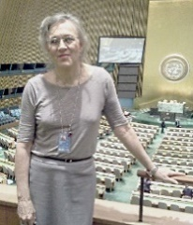 | Inactive Hestia’s New World email | https://groups.google.com/g/HestianWorld
 |  | Google search | Hestia search on Google
 |  | Hestia mentions in RNS research notes | Hestia Mentions on Reading Nature’s Signals
Pat Thompson & writing Links
 | Pat Thompson | Google Search | https://www.google.com/search?q=yelena+vladimirovna+mayakovskaya
 |  | Accidental Theorist Ch9,10 - excerpt | https://synapse9.com/HestiaRef/AccidentalTheorist-Ch9,10text.pdf
 |  | Accidental Theorist Diagrams- excerpt | https://synapse9.com/HestiaRef/AccidentalTheorist-HH_SystemDiagrams.pdf
 | Yelena Vladimirovna Mayakovskaya | Accidental Theorist Prologue- excerpt | https://synapse9.com/HestiaRef/AccidentalTheorist-Intro&Prologue.pdf
 |  | Fatal Abstraction- excerpt | https://synapse9.com/HestiaRef/FatalAbstr-p85.pdf
 |  | In bed with Procrustes- excerpt | https://synapse9.com/HestiaRef/InBedWithProcrustes-Intro&Prologue.pdf
 |  |  | Available on Amazon and Abebooks

Back to top
JLH

