Discussion

Friends were visiting Crete to be marries this week
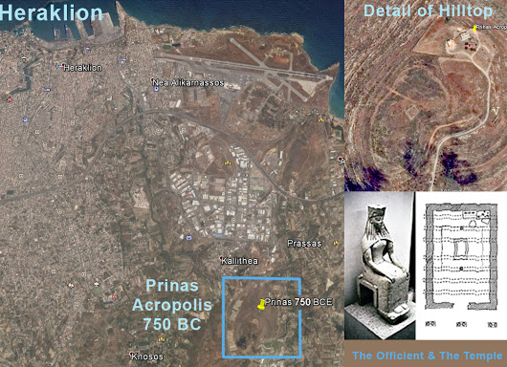
… after going to Greece, in part looking for a place for their marriage, so I gladly sent them this!...
If looking for a spot,... ;-) how about a sacred early acropolis in Crete, like Prinias, where the form of early Greek temples may have emerged.

This is a real find. – leading to a likely important short (1570 word) essay.
It's a new way to look at the whole cultural and architectural history surrounding the ancient bronze age Aegean hearth and home culture. It appears to be both the origin of many of the family traditions of home centered societies and architecture as a fine art.
The long enduring ancient Aegean home culture would have been origin of Hestia's role in mythology, as "guardian of hearth and home" and as the first of the gods in the proto-Greek pantheon, and why her humble depiction and role in ancient Greek religion are so very different from other power-personalities of the Greek gods. The building form of homes designed to be centered on a great hearth is what is easiest to document. Even in its oldest versions it displays the enduring high art and idealism for which high classical Greek architecture is known... with a 2500 year cultural tradition of design.
Being a rather scientific design for serving a culture centered on maintaining a perpetual flame and way of life around a literal family circle, also displayed artfully placed columns to solve all the building problems of living around a round hearth at the center. It's the fitting of all those patterns that in the end is most persuasive. That culture's way of living is not well documented, only clearly implied, as what would require the large round hearth (big round) as the focal point of its social life and the unnecessarily expensive architecture required to have a large room for equitable gatherings around an open hearth. It's a very unusual scientific design for living not found anywhere else in the ancient world, evidence of a culture that would be so long enduring and produce such beautiful art all along too.

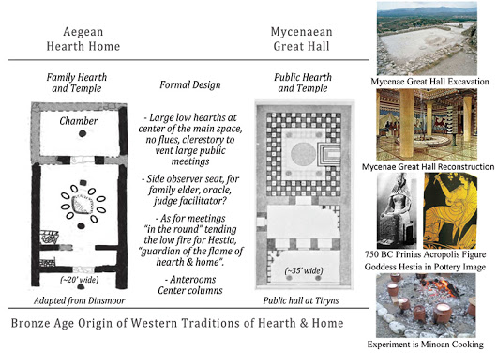
Architecturally that building form required a wide space, and having only relatively short trees... required columns in the middle of the space to support the long roof spans, and allow a vent for the low fire maintained at the center. The entrance to the Aegean hearth home still remained in the center, so the entrance was on the same line as the central columns, also prominently in the middle. That's the unusual geometry that also characterizes classical Greek architecture, the big round hearth at the center of the room and columns in the middle of the room to allow the hearth to be at the center of a large meeting room, the family center when a family home, a village center when a village center, a government center or spiritual temple when a great cultural center. It's a form of domestic home design seemingly only found in Bronze Age Aegean culture, but may be repeated only for the temples of some other cultures.
That wide room, housing a perpetual low flame to gather around. created an iconic ceremonial building type. We now find the culture that invented it in our own traditions of hearth and home. The architecture of great columns at the entrance was co-opted, however, to symbolize the centers of wealth and power,... That original symbolism for housing "great treasure", celebrating the treasures of home and equitable living, was reversed in meaning. It came to symbolize and celebrate ever growing inequities through centrally controlled wealth and power.
You see it in the familiar modern iconography of Modern Classical Greek architecture, at the entrances of banks and governments, as centers of wealth and power. The earliest examples of the Aegean hearth home were found at the lowest level layers of the excavation of ancient Troy, seeming to represent a common family and public regional culture centered on the Aegean sea, at the dawn of the Bronze Age~3300BC.
The design displays a peculiarly refined and democratic features for settled living, stone houses with indoor hearths at the center, for maintaining perpetual flames and to gather around. Dinsmoor notes that the form disappeared to reemerge again after invasion multiple times, and their traditions of hearth and home being the root of the traditions of modern Europe and the West. The architecture provided the model for Minoan and Mycenaean public space designs as great egalitarian meeting spaces, as well as inspiring the Classical Greek architecture and the design of public halls that became the centers of Greek democracy.
The authoritarian cultures of the Mediterranean to follow also use the same architectural forms for their high temples, for symbolizing the supremacy of their power and laws, in endless conflict with the home cultures that continued to spread using the egalitarian principles that remain the foundation of civilization.
There's a very curious break in the historical record I may have found the true secret of. That is the curious absence of written GREEK history for the "hearth home" building form. They are occasionally mentioned by Homer, translated to English and called "Megarons" as if only referring to the monumental forms, with no hint at all of where this mysteriously complex and perfected design came from. So it's been something of a mystery to architects who perceive the uniquely complex perfection of the building type, and wanted to know what culture it really came came from to make sense of modern architectural history.
Why the architectural history doesn't address the very long heritage and archaeology of the ancient family and community home design is the puzzle. Homer wrote before modern Greek developed, and the way he was translated into English seems to have used English pronunciation, with translators preferring the hard 'g' sound when the actual Greek pronunciation, still today, would have been with a soft 'g'. I wondered if said with a soft 'g' the word might refer to the big round hearth that defines it, and felt a similarity between the hard sound of "megaron" had some hint of "big round" as "mega-round", and then checked the modern Greek.
Sure enough the modern pronunciation refers has those sounds, "mega" and "giro" but with a soft 'g' or 'y'. Checking if the Greek word for 'round' would fit turned up "gyro" as the root term corresponding to the Greek 'round'. I think it implies that the natural Greek meaning for what Homer referred to (if said with the soft 'g') was indeed naming the building type for the great hearth at its center. You can interpret the linguistic evidence yourself, using Google Translate, English to Greek, and comparing the pronunciation for the two names for the same thing, to see if the ancient Greek word should have been translated "megyro" not "megaron".
https://translate.google.com/?hl=en#en/el/megaron
I think it's really an unavoidable conclusion when you get all the pieces together and see the images of how the humble very scientific hearth-home building form survived for thousands of years to then be found in the centers of Minoan, Mycenaean and Greek high cultures. It was then imitated as formal design by others too, including us, but without the original centering on a strong family circle, which for modern home design still serves but in much more varied informal ways.
That correction of the mistaken translation of the proto-Greek, to use a soft 'g' rather than an hard one... connects the historical references to the unusually enduring. now ~5000 year old, Aegean cultural tradition of building homes centered on a great low hearth for long meetings of a family circle as the common link. That begins the story into the historical era, and with both Greek architecture and democracy arising from the same enduring family circle and architectural design tradition. Dozens of variations on the same 'megyro' style public buildings surrounded the public space of the Athens Agora, displaying the even more ancient building designs for family meeting, as the origin of Greek democracy too. As elsewhere in the ancient world, it seems the emergence of high traditions of societal organization were then no match at all for the forces unleashed when that high degree of organization enabled the accumulation of great wealth, and the great battles over it... the prosperity leading to self-destructive authoritarian rule, breaking the magic spell and falling apart.
Sorry..., this is informal archaeology, the author's way of putting together a provocative story, however well founded. It's based on my long experience as an architect and understanding of how building forms serve common cultures, combined with my diverse studies in general systems ecology. I drew it from widely browsing the evolving building forms that emerged in the 3000 years of Aegean, Minoan, Mycenaean as well as classical Greek cultures, reading Dinsmoor's Architecture of Ancient Greece and Burkert's "Greek Religion", Renfrew's "Archeology of Language". Other hints on the cultural transitions involved came from Tainter's & Diamond's work on the collapse of complex societies, coupled with the serious feminist historians studying the rise of domineering authoritarian cultures (which then fail), and learning to "deconstruct the revisionist histories" reading Pat Thompson, Eisler, Songe-Moller and others. Fischer's decoding of early Minoan scripts, and readings on how modern Greek language developed from the Minoan scripts was important for understanding why the use of written language for descriptive records or story telling seemed to be such a delayed invention. It's then from a "pattern language" view of all those "forces at play" and spying some of the "simplifying relationships resolving them all together" that I put my descriptive picture from. I think the general picture is solidly based, though there's tremendous room for filling in the details, and reinterpretation, as well as tying it in with other old world cultures and traditions.

The group has been quiescent for a while.
I'm most interested in the origins of the archetypes for Hestia and Hermes, and the relevance of the various roles for "attending to home" and "attending to travel", they seem to originate from, and how they changed in history. Those are relevant to me both socially and scientifically as among the deepest of natural polarities and principles of organization in life.
Tentatively it seems the Minoan culture seemed to have the balance right, but it was lost in the natural and political disasters of the 2nd millennium BCE, and daughter civilizations have been searching in vain for how to rediscover it, ever since.... Contributions with any related interest welcome.

