Just to start it off, here's a copy of an email I sent to Helene,
introducing my recent excitement with finding how very closely Pat Thompson's Hestian language fits with my Natural Systems language. In addition to the home of a living system being the niche that it makes for itself, it's that the archetypal role of Hestia, as "guardian of the sacred flame of hearth and home" corresponds directly to the "continuity of living organization" that I trace with my natural science of self-organizing systems.
---
9/8/13 Helene,
I think you are right on track here. Though the Latin is beautiful I think common English is actually more clear. Isn’t the idea of “res nullius” already a conceptual enclosure of the commons, reflecting the Hermian revision of the language, and making all of nature subject to human control??
The meaning given in the Wictionary appendix of Latin phrases states “res nullius” as meaning:
“Goods without an owner. Used for things or beings which belong to nobody and are up for grabs, e.g., uninhabited and uncolonized lands, wandering wild animals, etc. (cf. terra nullius, "no man's land").”
- http://en.wiktionary.org/wiki/Appendix:List_of_Latin_phrases_(P%E2%80%93Z)#R
I really like Pat Thompson’s way of deconstructing Latin using that Hestian/Hermian dichotomy (and also her Systems Thinking approach). The Latin reflects the Roman culture’s mental reduction of all things to their use value to humans, and in doing so erases the working relationships owned by nature from the meaning of “all that is not owned” (or not yet conceptualized I guess) by humans!
- http://synapse9.com/HestiaRef/AccidentalTheorist-Ch9,10text.pdf
- http://synapse9.com/HestiaRef/LifePlans-Ch14SystemsThinking.pdf
For the Hestian way of expressing it turn to the far richer meaning of the common words of English. In English gives you the symmetry of terms “internal” and “external” for any given system, whether that system is of ownership, energy use or a community, etc., as the most general case. What it boils down to from the Hestian view is the distinction between “home” and “wilderness”, though, as what “internal” actually means in almost any context is “home to something”. Isn’t that a nice way of putting it? :-)
As to where to start this discussion, it’s possible that my having (without discussion) reversed Lisinka’s statement in the draft letter “As nature, herself is of course not ‘a commons’ ”, may have been one of the irritants causing the recent exchange. Is there a way to resolve that?
Is there some important distinction lost if we consider “the wilderness” or “nature as a whole” to be “a commons”? From human perspective it might have unknown bounds and unknown organization perhaps. I was thinking the all that would be lost is the image of nature as a picturesque image, and what would be gained is Gaia as a working system of partnerships, the organism underlying our picturesque images of nature.
Jessie

Beginnings and purposes

Personally, I feel extremely fortunate…
… to have gotten a chance to spend a good bit of time with Pat Thompson last summer and fall. I’m actually a physicist and architect, who has spent decades studying the dynamic evolution of natural systems. I found Pat's understanding of natural systems, seen through a Hestian lens, to be particularly fresh and insightful.
We both see the initial paradigm of natural organization is “home”, a domain of self-organization within a protected space, for sustaining its "sacred flame”. It does that, of course, partly by also creating an external space of intimate mirror relationships in its near environment, or a 'niche". So, we see Hestia and Hermes as truly eternal archetypes of natural order.
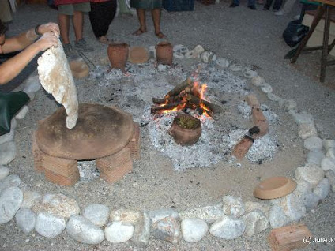
I also found our reasons for studying it unexpectedly close too. The natural systems view helps a lot in retracing the ancient evolution of human cultures from reflecting the natural archetypes of “home and its communications” (Hestia and Hermes), to become dominated today by the conceptual archetypes of modern man, “business and power” (rules and rulers). More familiar is to describe that shift as the rise of male dominated hierarchy an marginalization of the feminine, as part of human societies becoming disruptive rather than holistic and losing touch with their own real interests.

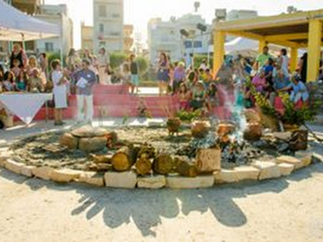
I think she and I made a lot of progress, in case you know of anyone who studies and likes to talk about such things. One of my discoveries since I last talked with her last fall is the apparent Minoan origin of Hestia, at least 1000 years before the early Greek legends. The great ceremonial hearth that Hestia is known to be the guardian of, as the center of the classic Greek temples called “Megarons”, and at the center of Greek households and called the “navel of the earth”… appears to have first appeared as the design of the great “live-in kitchens” of ancient Minoan homes.
The likely original use of that now very curiously symbolic hearth, seems unavoidably for a family to sit around, as it’s communal ‘family circle’, taking the time around the fire to eat and kindle the “sacred flame” of their family unity (or so this girl imagines…). To help people of today to think about and try to understand how all these lost ways of living could have fit together, I include some photos of Minoan culture reconstructions.
The story goes on from there, how the Minoan culture was probably the model of the myths of Atlantis, so remarkably communal, rich, artistic and literary, it still serves as a lost ideal of how man could live. It was also indeed literally drowned by a great tidal wave from a nearby volcano, Thera, in 1600 BCE, and all its ships and coastal development sunk into the sea.
Who knows, though, whether Minoan culture would have survived its own achievements. It was in fact terribly threatened by its own success, just as we are today so threatened by our success being the direct cause our own environmental demise!! There’s evidence in the Fischer translation of the “Phaistos” disk that the real demise of Minoan culture may have been its wealth, and not the volcano.
Though the waves surely erased most of the evidence, the disk provides a report on the life of the island being threatened by pirates and desperate to build defenses, seemingly after it was too late…
I think this is just a wonderful way to open up whole story of what is happening to us, right now too.

Subjects
If a "home" is the place a living culture makes for itself, and Hestia is the archetype Guardian of the Sacred Fire of Hearth and Home (keeping "the home fires burning" in modern phrasing). "Homemaking" must be about "making homes" in that Hestian sense, the true meaning totally different from the one assigned to it, close to: "chores of the home servant", from the dominant Roman male, "Hermian," culture of control (rather than nurture) we still live with in large part today.
So "home-making" becomes "devotion to nurturing and protecting the "sacred flame" of the living culture of the home, living and passing on its deep family traditions and knowledge of life. Which... really does FIT much better what the actual job of home-making DOES, and always did. It just just stopped being recognized as an archetypal role in society, originally, the principal archetypal role.
References

